Petition to the
InterAmerican Commission for Human Rights
Prepared in Quito: June, 2010

Background: In June, 2010 – approximately 7 months after the illegal kidnapping and deportation of Gregory James Caton – Cathryn Caton retained an attorney in Quito to examine the case and find legal remedies for addressing the many violations of international and Ecuadorian law that surrounded her husband’s case. In response to this request, Dr. Moreno repaired the following lawsuit.
The estimated cost of litigation was said to run more than $30,000 – a sum that well exceeded what Mrs. Caton was able to pay. Nonetheless, the importance of this document remains . It well summarizes the extreme lawlessness surrounding the case and highlights the many laws that were committed by the U.S. State Department, acting through its Consulate Office in Guayaquil, as well as the Ecuadorian authorities who were secretly acting upon the dictates of the Consulate.
Australian litigator Jerry Prus-Butwilowicz, himself a former prosecutor with the International Court at the Hague, examined this case in considerable detail – pro bono – and came to the conclusion that not only had the U.S. State Department committed a potpourri of international law violations, but that the Ecuadorian authorities involved – even under a liberal interpretation of Ecuadorean law – had committed high treason.
This document is provided to elucidate those violations.
What follows is the original petition, drafted in Spanish, followed by its English translation.

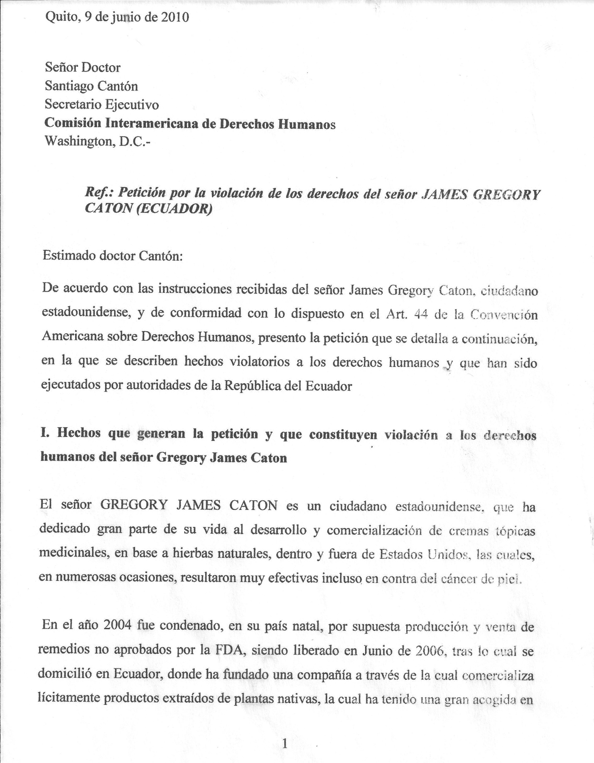

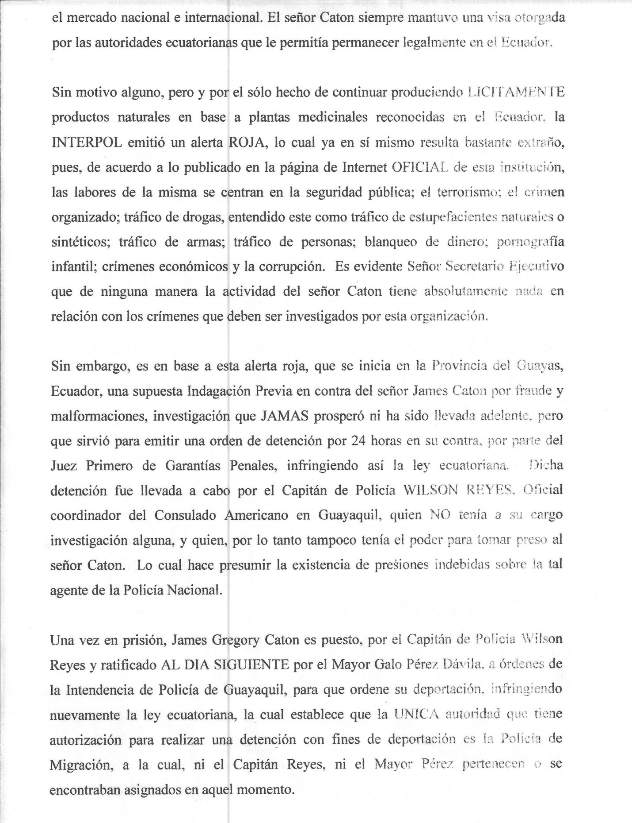

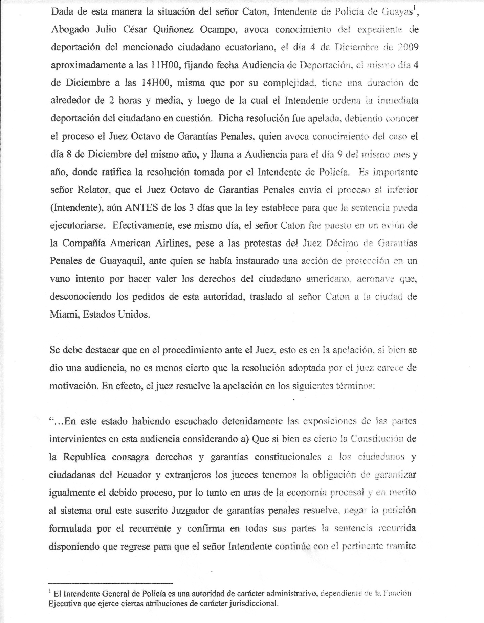

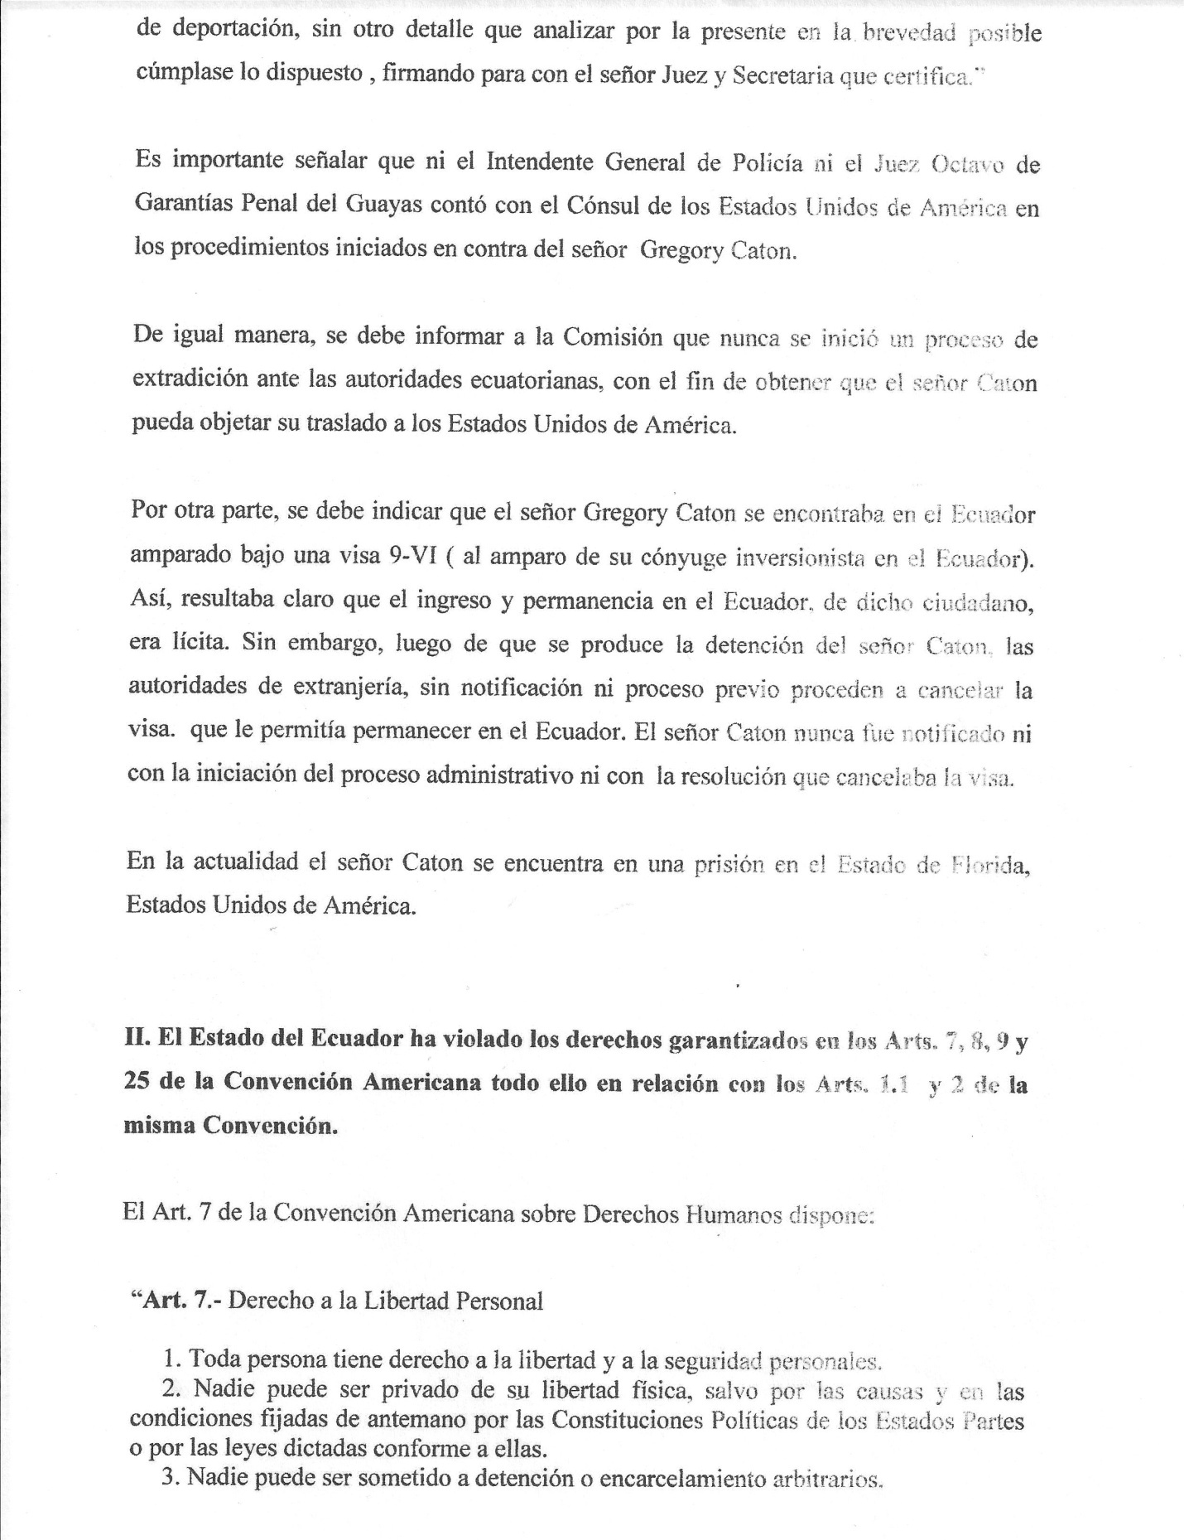
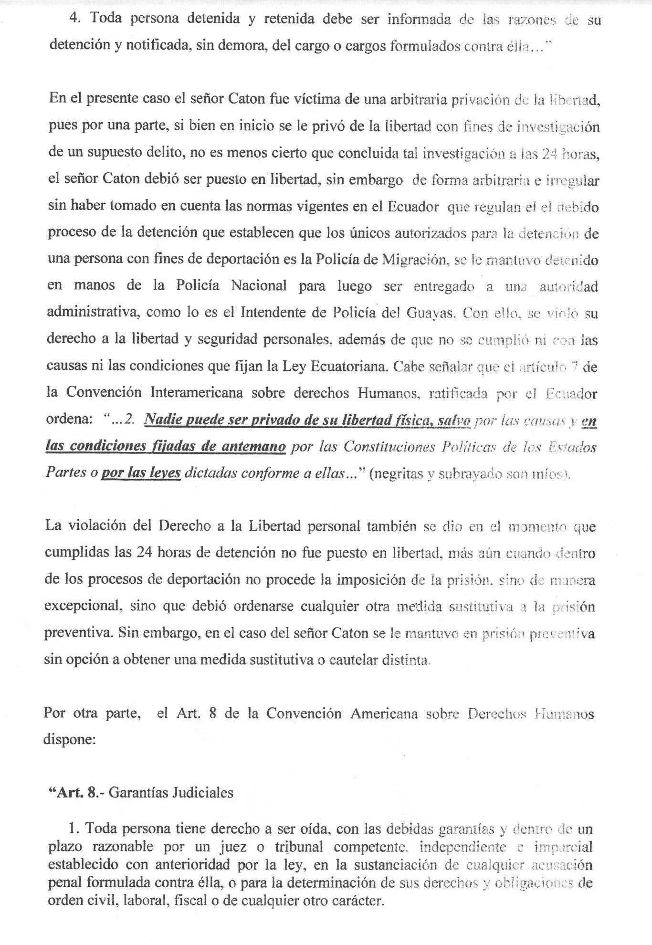
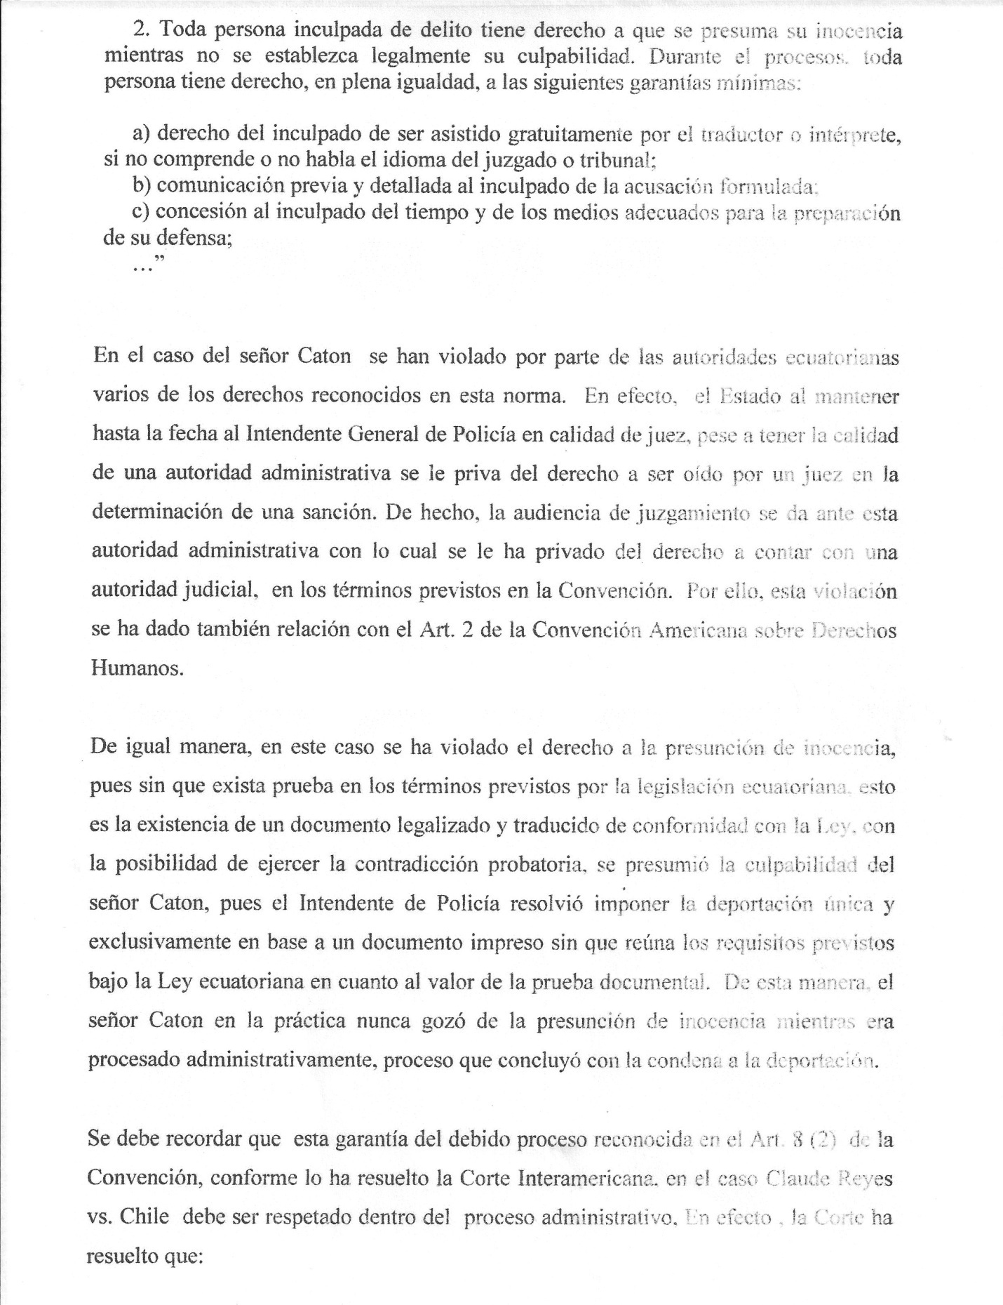

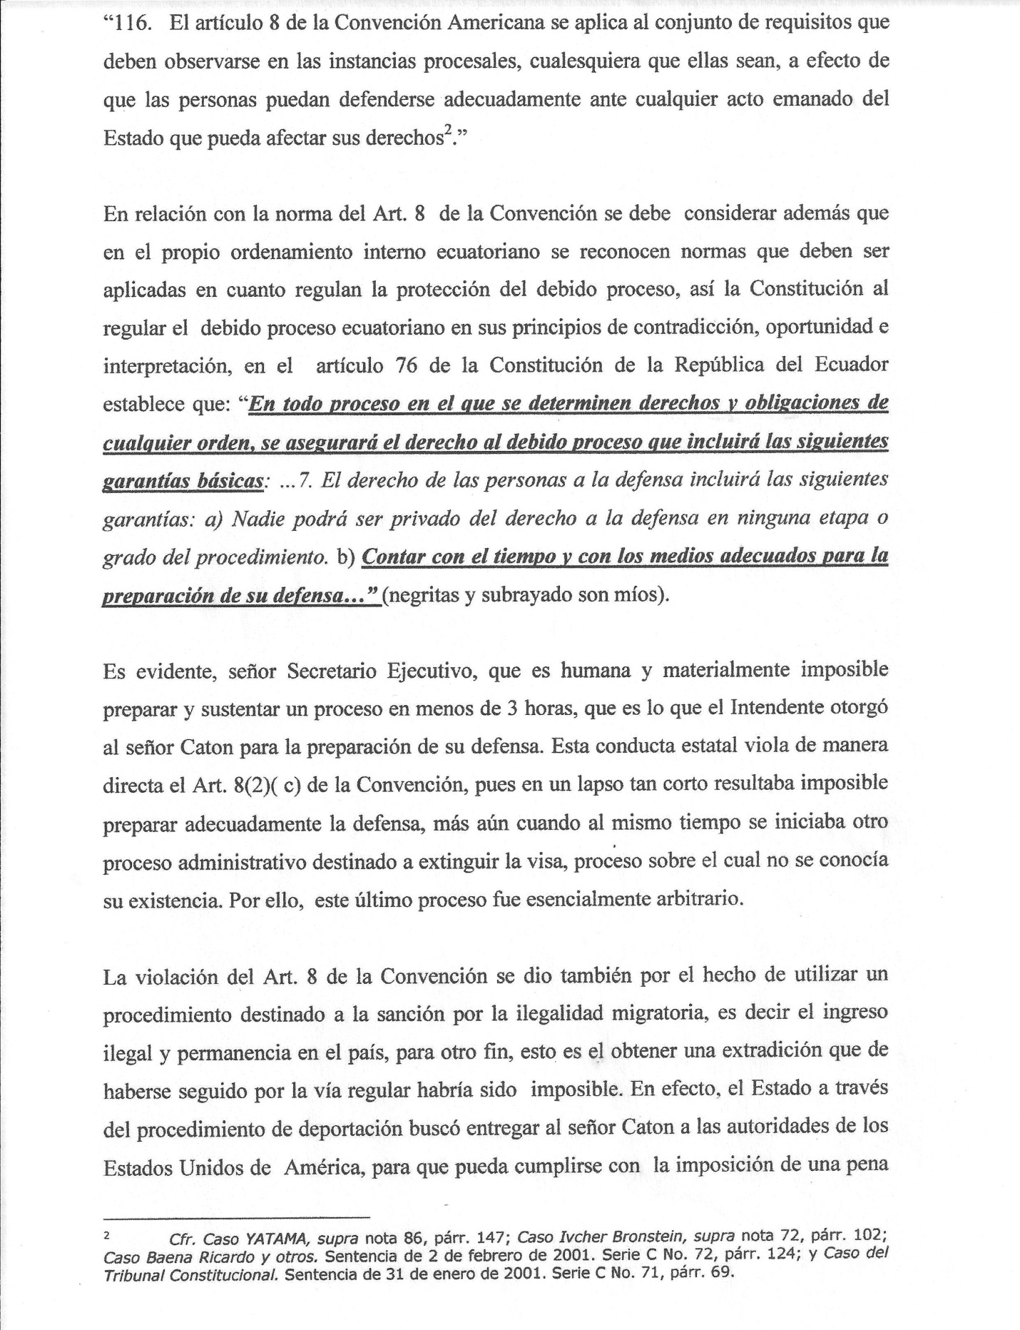

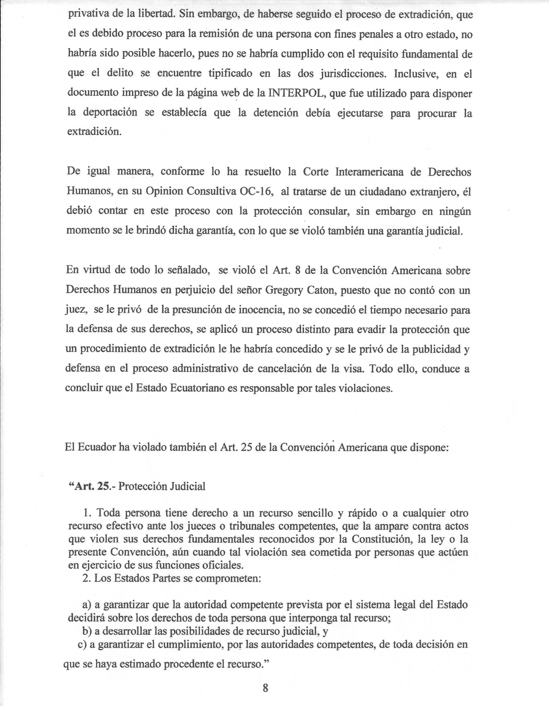

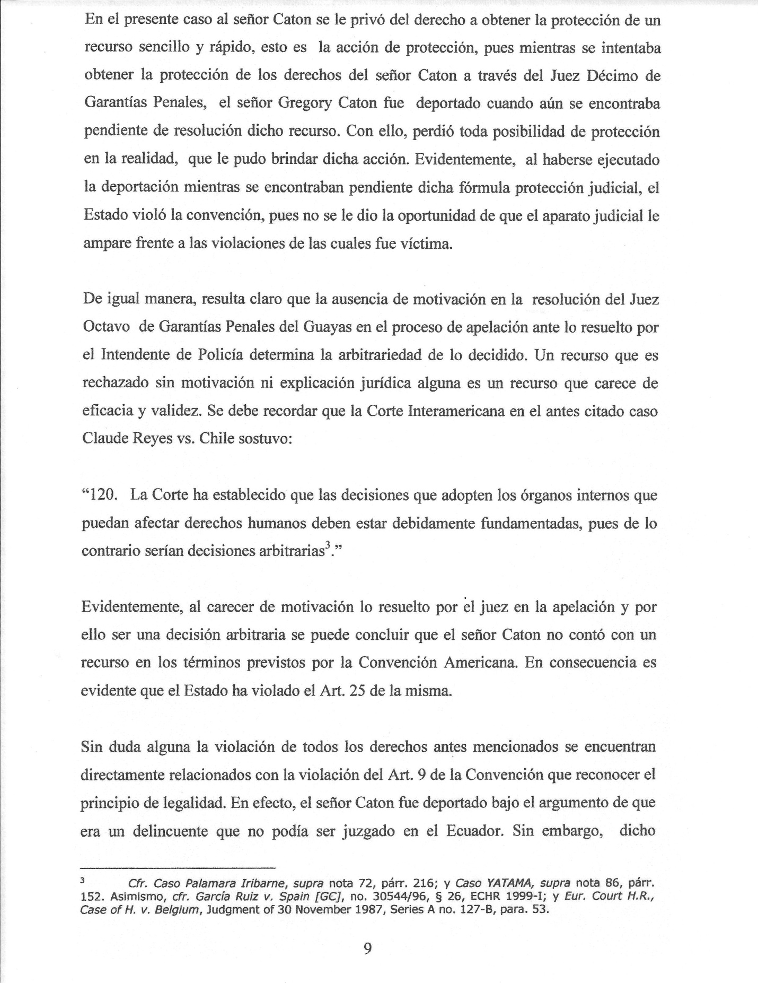

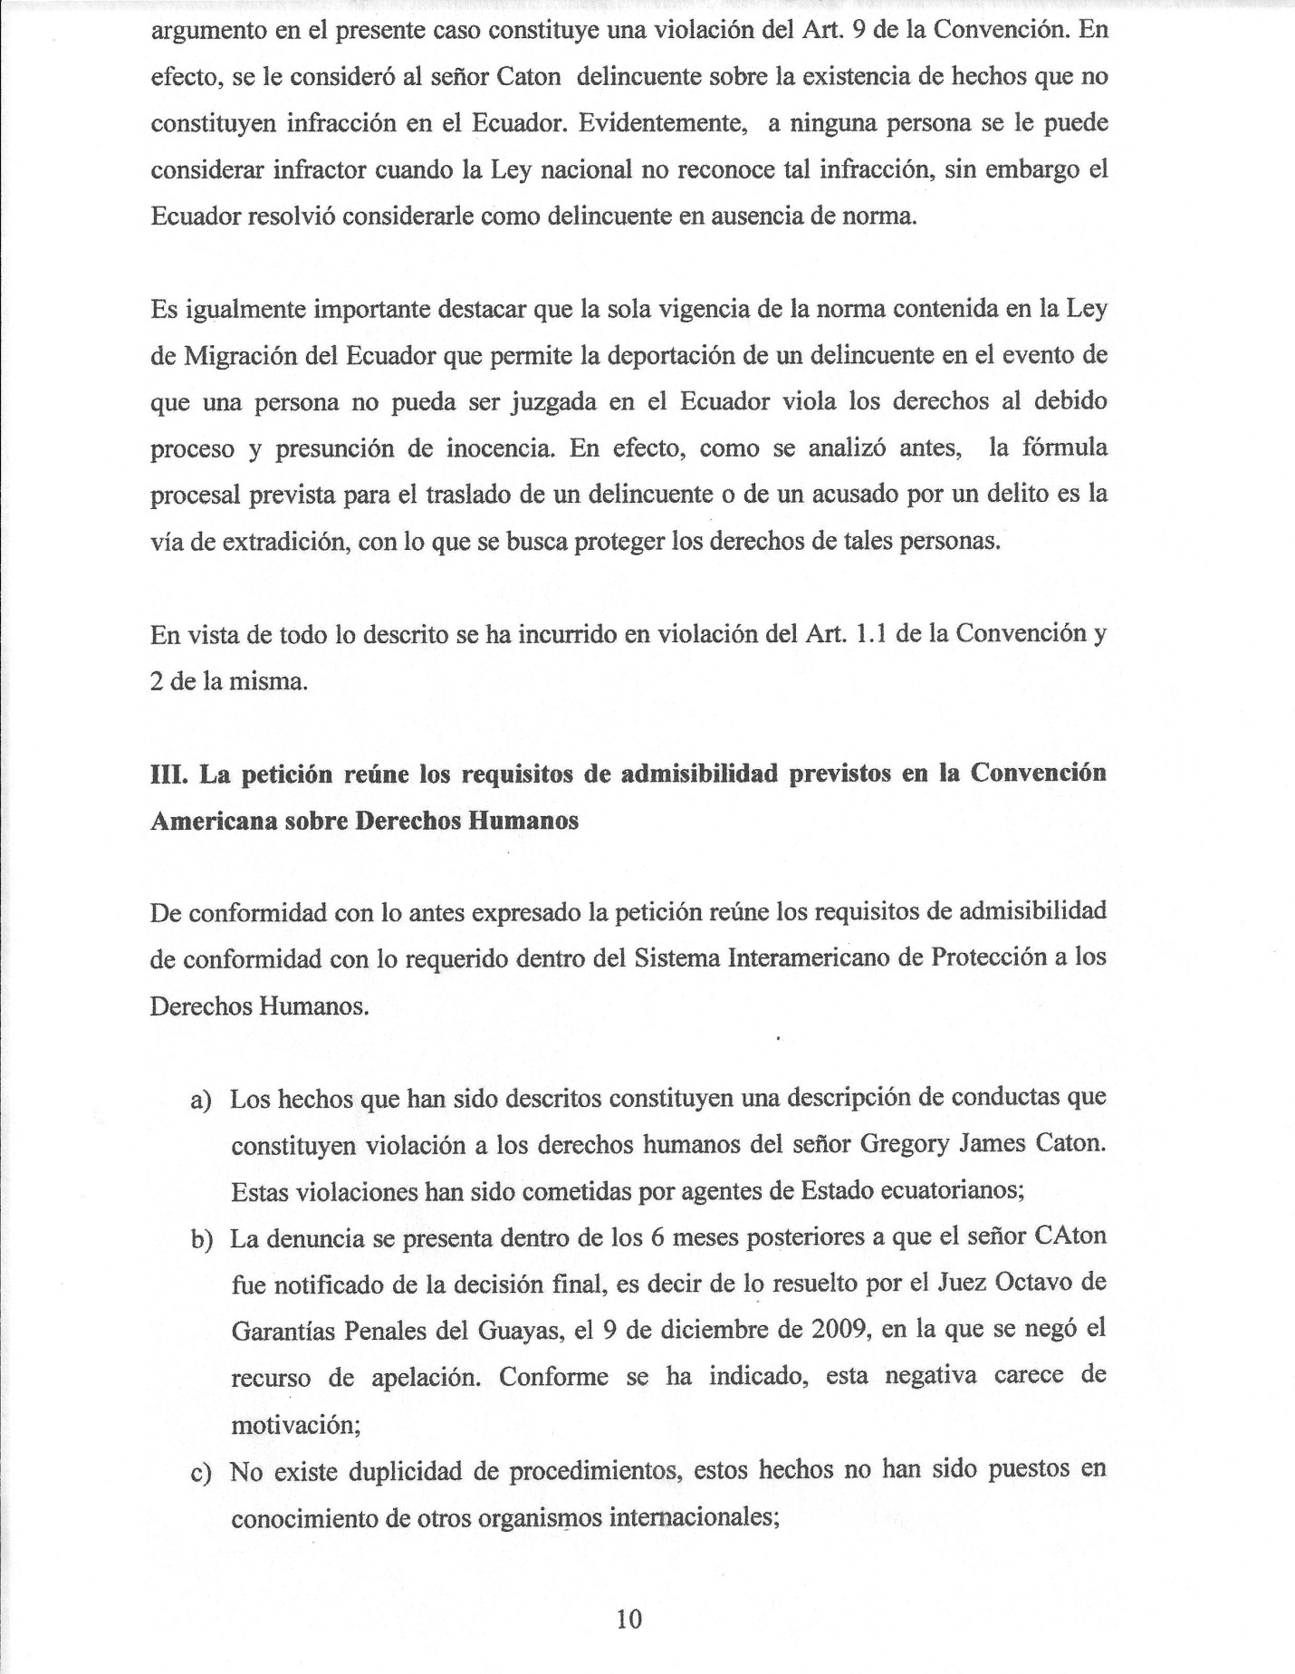

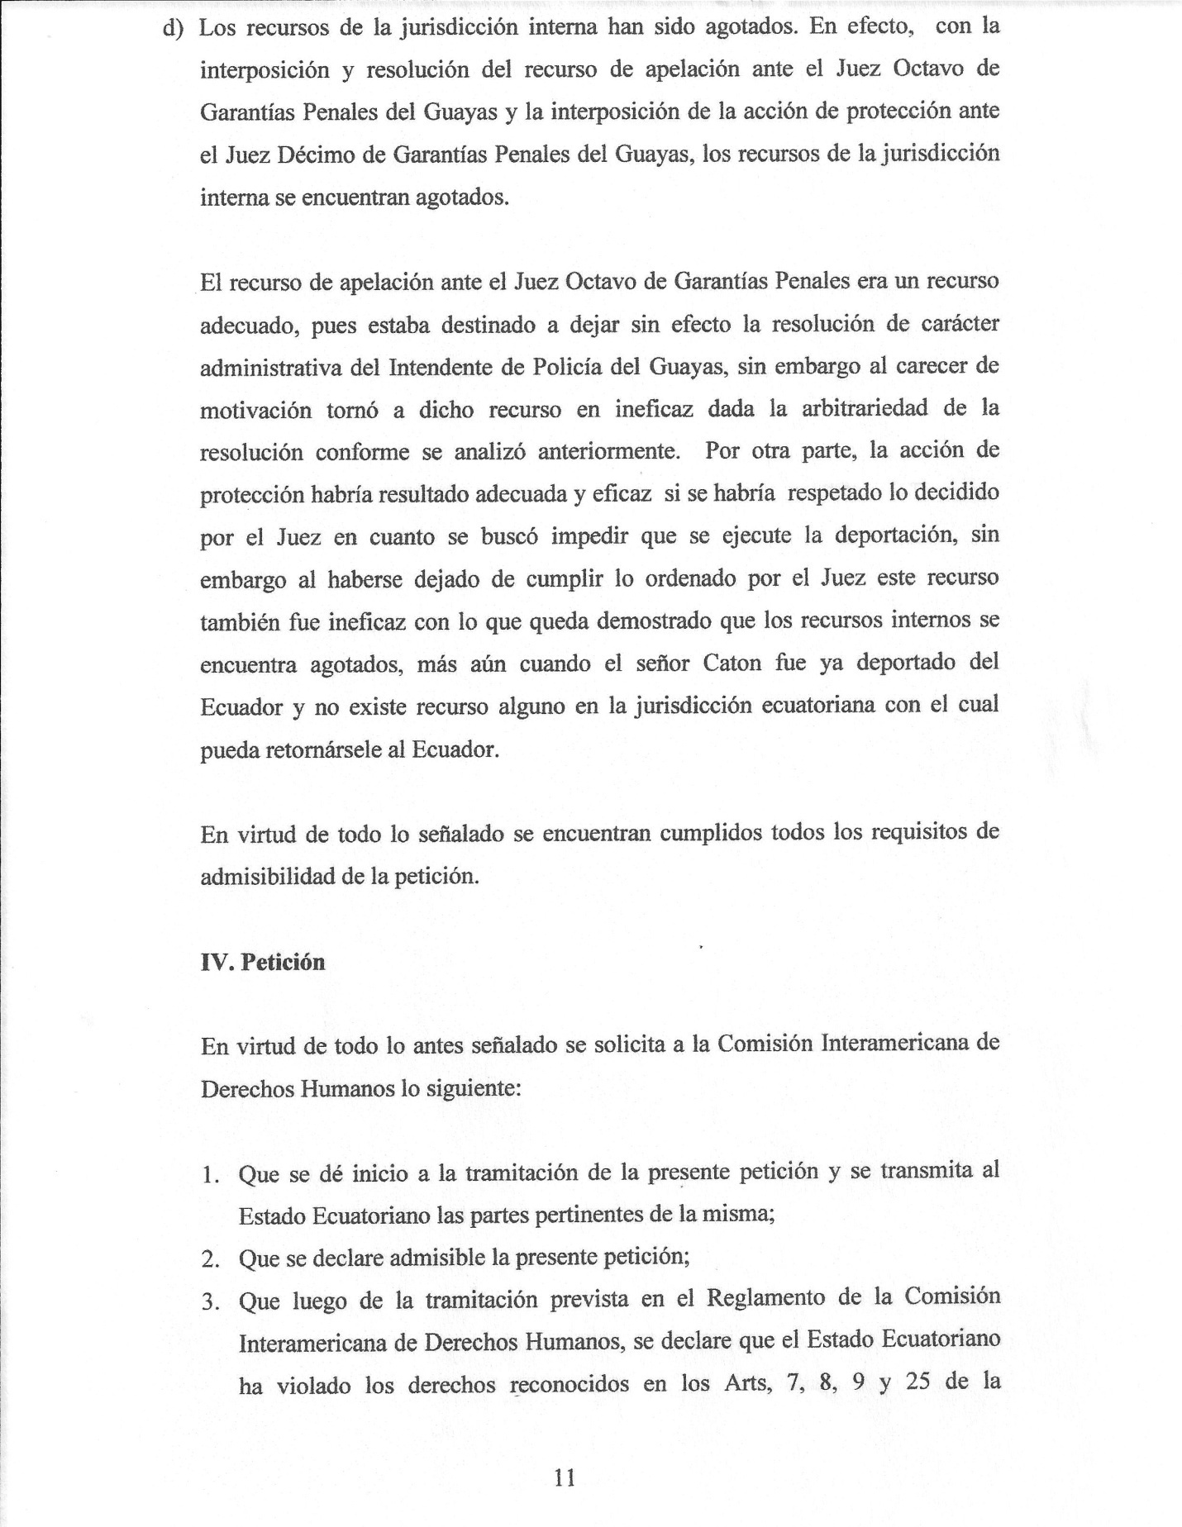

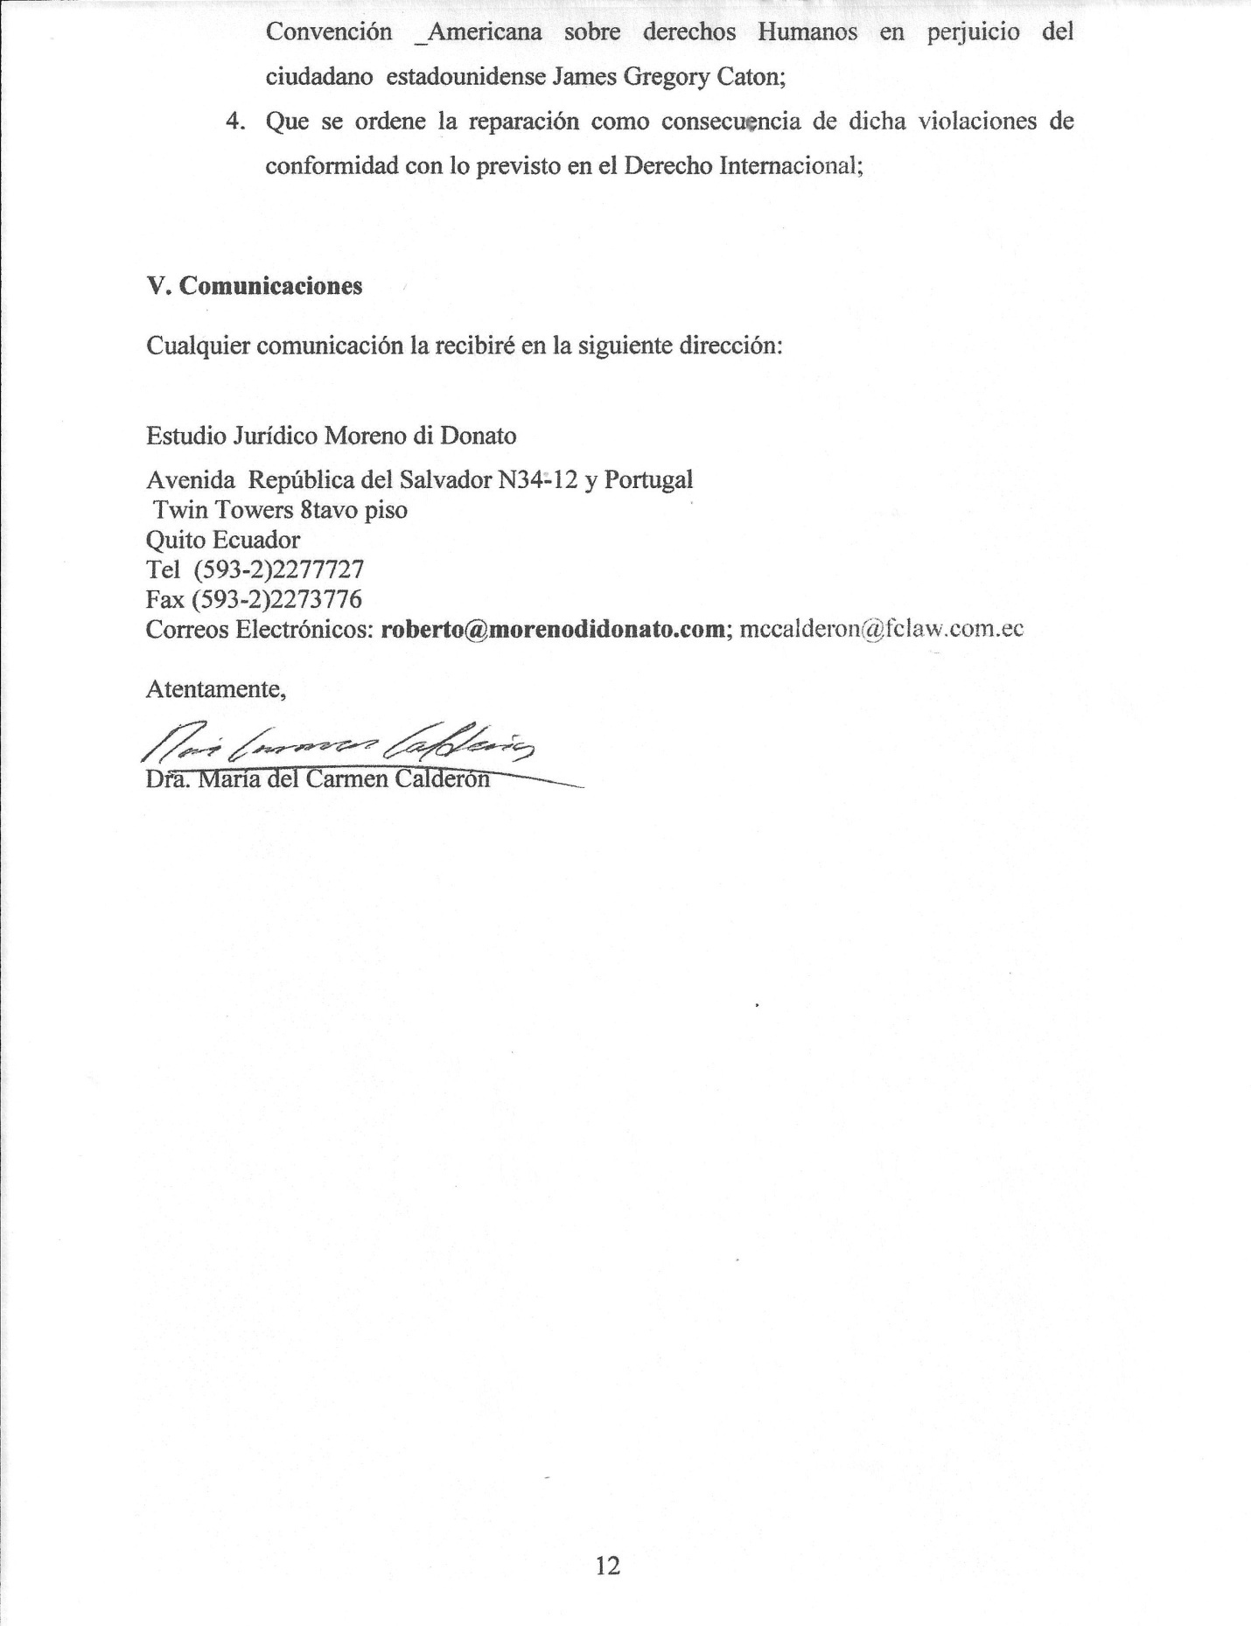

Quito, June 9, 2010
Doctor
Santiago Canton
Executive Secretary
Inter American Commission of Human Rights
Washington, D.C.-

Ref.: Petition for the violation of rights of Mr. JAMES GREGORY CATON (ECUADOR)

Dear Doctor Canton:
In accordance with the instructions received from Mr. Gregory James Caton, American citizen and in compliance with the Art. 44 of the American Convention of Human Rights, I present this petition that is detailed below wherein human rights have been violated by the authorities of the Republic of Ecuador.
- Facts that generate the petition and constitute the violation to the human rights of Mr. Gregory James Caton
Mr. GREGORY JAMES CATON is an American citizen who has dedicated most of his life to the development and marketing of medicinal creams of external use that are produced with natural herbs. These were sold in and out of the United States and were very effective in many occasions, including against skin cancer.
In 2004, he was condemned in his country for the alleged production and marketing of remedies that were not approved by the FDA. He was released in June, 2006. Then, he moved to Ecuador where he founded a company that legally markets products extracted from native plants which have been successful in the national and international markets. Mr. Caton always had a visa issued by the Ecuadorian authorities that allowed him to legally stay in Ecuador.
With no reason at all and for the only fact of continuing with the LEGAL production of natural products based in medicinal plants of Ecuador, the INTERPOL issued a RED alert. This fact is very strange because, according to the published information that is found on the official web page of this institution, its activity is centered in public safety such as terrorism, organized crime, drug trafficking (natural or synthetic stupefacient substances), arms trafficking, money laundering, child pornography, economical crimes and corruption. It is evident that Mr. Caton’s activity has no relationship with the crimes that should be investigated by this organization.
However, based on this red alert, an alleged investigation started against Mr. Caton for fraud and malformations, such things did not continue but served to issue an arrest order lasting 24 hours. It was issued by the First Judge of Criminal Guarantees, thus violating the Ecuadorian law. Such arrest was carried out by the Police Captain Wilson Reyes, coordinator of the American Consulate in Guayaquil. He did not conduct any investigation and did not have the authority to arrest Mr. Caton. This fact suggests the existence of illegal pressures on such a police agent.
Gregory James Caton, once imprisoned by Captain Wilson Reyes, and ratified the following day by the Chief of Police Galo Perez Davila of the Police Department of Guayaquil, was then ordered deported, violating the Ecuadorian law once more. Such law establishes that the ONLY authority that has power to arrest in order to deport is the Immigration Police -- to which neither Captain Reyes nor Perez belong, nor were they allocated to this entity at that moment.
With the foregoing situation of Mr. Caton, Police Mayor of Guayas, Atty. Julio Cesar Quiñonez Ocampo, took over the case of the deportation of the above mentioned Ecuadorian citizen on December 4, 2009 at approximately 11H00, and treated it with expedience. He set the date for the Deportation Hearing on the same day, December 4, at 14H00. Because of its complexity, it lasted around two and a half hours. After it ended, the Mayor ordered the immediate deportation of the mentioned citizen. Such resolution was appealed and the Eighth Judge of Criminal Guarantees, knowing the process, took over the case on December 8 of the same year and called for a Hearing on the ninth day of the same month and year, where the resolution taken by the Police Mayor was acknowledged. Mister Reporter, it is important to note that the Eighth Judge of Criminal Guarantees sent the process to the lower authority (Mayor), even BEFORE the three days that the law establishes to get a judgment had expired. Effectively, on that same day, Mr. Caton was placed in an American Airlines plane despite the protests of the Tenth Judge of Criminal Guarantees of Guayaquil before whom a protection petition was established in a vain attempt to assert the American citizen’s rights. Said aircraft, ceasing to recognize the orders of this authority, took Mr. Caton to Miami, United States.
It must be emphasized that in the proceeding before the Judge, in this appellate hearing, it is not an exaggeration to say that the adopted resolution by the judge lacks of sound reasoning. In effect, the Judge resolves the appeal in the following terms:
“…In this State, after thoroughly hearing the expositions of the parties involved in this Hearing, considering a) that the Constitution of the Republic establishes constitutional rights and guarantees to the citizens of Ecuador and foreigners. We, the judges, have the obligation to guarantee the legal process. Therefore, for the sake of the procedural economy and in merit to the oral system, this undersigned Judge of Criminal Guarantees resolves to deny the petition of the appellant and confirms in all its parts the appellate judgment ordering the return (of the accused) so the Mayor can continue with the relevant procedure of deportation. Without any other detail to analyze and as soon as possible, (we should) comply with what has been established, signing by the Judge and the Secretary who certifies it.”
It is also important to indicate that neither the General Mayor of the Police nor the Eighth Judge of Criminal Guarantees of Guayas counted with the American Consulate in the process initiated against Mr. Gregory Caton.
In the same way, the Commission should be informed that an extradition process was never initiated before Ecuadorian authorities with the purpose of having Mr. Caton object to his transfer to the United States of America.
On the other hand, it should be known that Gregory Caton was in Ecuador protected by a 9-VI VISA (under his wife’s visa, an investor in Ecuador). That way, it was clear that the entrance and presence of this citizen in Ecuador was legal. However, after Mr. Caton’s arrest, the immigration authorities, without any previous notice or process, proceeded to cancel his visa. Mr. Caton was never notified neither by the initiation of the administrative process nor by the resolution to cancel his visa.
Currently, Mr. Caton is in prison in the State of Florida, United States. {Editor’s Note: Mr. Moreno, the attorney who drafted this document, did not know that Caton was transferred from FDC Miami in January and shipped to a federal holding facility in Breaux Bridge, Louisiana – where he was held until being shipped to Beaumont, Texas, in mid-June).

- The Ecuadorian State has violated the rights guaranteed on Articles 7, 8, 9 and 25 of the American Convention; all of them related to the Articles 1.1 and 2 of the same.
The Article 7 of the American Convention about Human Rights stipulates:
“Art. 7- Right to Personal Freedom
- Every person has the right to personal liberty and security.
- Nobody can be deprived of their physical liberty, except by the causes and conditions determined beforehand by the Political Constitutions of the Participating States or by the laws issued in accordance with them.
- Nobody can be arbitrarily held in prison.
- Every person who is arrested and detained must be informed of the reasons of such arrest and notified, without delay, the charge or charges formulated against him/her…”
- In this case, Mr. Caton was a victim of an arbitrary imprisonment. On the one hand, he was imprisoned with investigation purposes of an alleged offense; it is not less truth that once such investigation was concluded, after 24 hours, Mr. Caton should have been released. However, in an arbitrary and irregular manner, without respecting the current laws in Ecuador, he was arrested by the National Police and later transferred to an administrative authority such as the Police Mayor of Guayas. According to the laws, the Immigration Police is the only entity authorized to arrest a person with the purpose of deportation. His right to personal freedom and security was violated and the causes and conditions established by the Ecuadorian Law were not respected. It is worth mentioning that Article 7 of the Inter-American Convention about Human Rights, acknowledged by Ecuador, orders: “…2. Nobody can be deprived of their physical liberty, unless by the causes and conditions determined beforehand by the Political Constitutions of the Participating States or by the laws issued in accordance with them...”(bold and underlined text is mine).

The violation to the Right to Personal Freedom happened for not being released after serving 24 hours of arrest. Additionally, the imposition of prison is not applicable in the process of deportation, but, as an exceptional measure. There should have been an alternative measure to preventive prison. However, in Mr. Caton’s case, he was kept in preventive prison without the option to obtain an alternative or cautionary measure.

On the other hand, Article 8 of the American Convention of Human Rights stipulates:

“Art. 8. - Legal Guarantees
- Every person has the right to be listened to, with the due guarantees and within a reasonable deadline by a competent, independent and neutral judge or court established in advance by the law in the examination of any criminal accusation formulated against him or her, or to determine his or her civil, working or any other rights and obligations.
- Every person who is prosecuted of crime has the right to be considered innocent until his or her guilt is legally established. During the process, every person has the equal right to the following minimal guarantees:

- The right to be assisted by a translator or interpreter with no cost if he or she does not understand or speak the language of the court;
- Previous and detailed communication of the formulated accusation to the accused.
- The time and adequate means to prepare the defense of the accused.
…”
In Mr. Caton’s case, various rights recognized in this law were violated by Ecuadorian authorities. In effect, the State denied Mr. Caton the right to be heard by a judge in order to determine a sanction. Instead, the General Mayor of Police acts as a judge until the present date even though he is an administrative authority. In fact, the hearing was held before this administrative authority, denying the accused the right to count with a judicial authority as established in the Convention. For this reason, this violation relates to Article 2 of the American Convention of Human Rights.
Also, the right to the presumption of innocence has been violated in this case because Mr. Caton was considered guilty without legal proof such as the existence of a legal and translated document with the possibility of arguing the contradiction. The Police Mayor resolved to impose the deportation based on only one printed document without having the requirements established by the Ecuadorian Law in order to have documented proof. This way, Mr. Caton was never benefited with the presumption of innocence while he was processed administratively. Such process concluded with his deportation.
It should be remembered that the guarantee of this legal process recognized in Article 8 (2) of the Convention, resolved by the Inter American Court, in the case of Claude Reyes vs. Chile should be respected in the administrative process. In effect, the Court has resolved that:
“116. The Article 8 of the American Convention is applied to the group of requirements that should be observed in the procedural instances, whichever these can be, so the person can defend himself/herself adequately before any act from the State that can affect his or her rights².”
In relation with Article 8 of the Convention, it should also be considered that the same Ecuadorian internal laws recognize laws that should be applied in order to regulate the protection of such legal processes. Therefore, the Constitution regulating the Ecuadorian process in its principles of contradiction, opportunity and interpretation in Article 76 of the Constitution of the Republic of Ecuador, establishes that: “In all processes where rights and obligations of any kind are set forth, the right to due process of law shall be ensured, including the following basic guarantees: … 7. The right of persons to defense shall include the following guarantees:
a) No one shall be deprived of the right to defense at any stage or level of the proceedings.
b) To have the time and means to prepare for one’s defense…” (Bold and underlined text is mine)
It is evident, Mr. Executive Secretary, that it is human and materially impossible to prepare and support a process in less than 3 hours. This is what the Mayor granted Mr. Caton for the preparation of his defense. This conduct directly violates Art. 8(2)(c) of the Convention because it was impossible to adequately prepare his defense in such a short period of time. Additionally, at the same time another administrative process started, it was assigned to extinguish his visa. Its existence was unknown. Therefore, this last process was essentially arbitrary.
The violation to Article 8 of the Convention also occurred for using a procedure assigned to the sanction for migratory lawlessness, in other words the illegal entrance and permanence in the country. Acting legally, it would have been impossible to be extradited. In effect, the State, through a deportation process, found a way to send Mr. Caton to authorities of the United States of America so they could arrest him. However, if the extradition process would have been followed, which is the legal process to transfer a person with criminal purposes to another state, it would not have been possible because the fundamental requirement was not complied with. This requirement is to have the crime covered in the two jurisdictions. Also, in the document found on the web page of the INTERPOL which was used to order the deportation, it was established that the arrest should have been executed in order to procure the extradition.
In the same way, in accordance with the resolution of the Inter American Court of Human Rights, in its Advisory Opinion OC-16, as he is a foreign person, he should have counted with the consular protection in this process. However, he was not provided with such guarantee at any moment, whereupon the judicial guarantee was also violated.
By virtue of all the above mentioned, Article 8 of the American Convention about Human Rights was violated to the detriment of Mr. Gregory Caton because the process did not count with a judge. He was deprived of the presumption of innocence; he was not given the time necessary to defend his rights; a different process was applied in order to evade the protection that an extradition process would have conceded him; and he was deprived of notice and defense in the administrative process of the cancellation of his visa. All of that leads to conclude that the Ecuadorian State is responsible for such violations.
Ecuador has also violated Article 25 of the American Convention that stipulates:
“Art. 25.-Judicial Protection
- Every person has the right to a simple and rapid appeal or any other effective appeal before the competent judges or courts in order to protect him or her against acts that can violate their fundamental rights recognized by the Constitution, the law or the present Convention, even though such violation would be committed by people who act in the exercise of their official functions.
- The Participating States have a commitment to:
- Guarantee that the competent authority provided by the legal system of the State will decide about the rights of every person that lodges such resource;
- Develop the possibilities of the judicial resource, and
- Guarantee the compliance by the competent authorities of all the decisions where the resource was estimated proper.”
In the present case, Mr. Caton was deprived of the right to obtain protection of a simple and rapid resource; this is the petition of protection. While the Tenth Judge of Criminal Guarantees was trying to obtain the protection of the rights of Mr. Caton, he was deported even when the resource was pending of resolution. With that, he lost all possibility of protection that such petition would have granted him. Evidently, executing the deportation while such judicial protection formula was still pending, the State violated the convention since he was not given the opportunity to have the judicial system to protect him against these violations that he was a victim of.
In the same way, it is very clear that the absence of reasoning in the resolution by the Eighth Judge of Criminal Guarantees of Guayas before the Police Mayor’s resolution, demonstrated the arbitrariness of the decision in the appeal process. A resource that is rejected without any legal reasoning or explanation is a resource that lacks any efficiency and validity. It should be remembered that the Inter American Court, as in the aforesaid case of Claude Reyes vs. Chile, upheld:
“120. The Court has established that the decisions that the internal organisms adopt which can affect the human rights should be legally supported, otherwise they would be arbitrary decisions³.”
Evidently, since the judge’s resolution lacked any reasoning in the appeal and therefore was an arbitrary decision, we can conclude that Mr. Caton did not count with a resource in the foreseen terms of the American Convention. In consequence, it is evident that the State has violated its Article 25.
Without any doubt, all of the aforesaid violated rights are directly related to the violation of Article 9 of the Convention that recognizes the Rule of Law. In effect, Mr. Caton was deported under the argument that he was a criminal who could not be judged in Ecuador. However, in the present case, such argument constitutes a violation to Article 9 of the Convention. In effect, Mr. Caton was considered an offender because of the existence of facts that do not constitute a violation in Ecuador. Evidently, nobody can be considered an offender when the National Law does not recognize such violation. However, Ecuador determined to consider him as an offender in absence of a rule.
It is equally important to mention that the validity of the rule contained in the Immigration Law of Ecuador that allows the deportation of an offender in the event that a person cannot be judged in Ecuador, violates the rights to the legal process and presumption of innocence. In effect, as has been analyzed above, the foreseen procedural formulation for the transfer of an offender or an accused of a crime is the extradition process, which itself attempts to protect those people’s rights.
Based on all of the described above, Articles 1.1 and 2 of the Convention were violated.

- The petition meets the requirements of admissibility foreseen in the American Convention about Human Rights

In accordance with the aforesaid, the petition meets the requirements of admissibility according with the required in the Inter American Protection System to Human Rights.
- The facts that have been described constitute a description of the conduct that considers a violation to the human rights of Mr. Gregory James Caton. These violations were committed by agents of the Ecuadorian State.
- The report was presented within six months after Mr. Caton was notified of the final decision: this means the resolution taken by the Eighth Judge of Criminal Guarantees of Guayas, on December 9, 2009 where the recourse to appeal was denied. According to the mentioned, this denial lacks of reasoning.
- The duplicity of procedures does not exist; these facts have not been brought to the attention of the other international organizations.
- The resources of the internal jurisdiction have been exhausted. In effect, with the lodging and resolution of the recourse to appeal before the Eighth Judge of Criminal Guarantees of Guayas and the lodging of the action of protection before the Tenth Judge of Criminal Guarantees of Guayas, the resources of the internal jurisdiction are exhausted.

The recourse to appeal before the Eighth Judge of Criminal Guarantees was an adequate resource since it was allocated to leave without effect the administrative resolution of the Police Mayor of Guayas. However, lacking of reasoning, such resource became ineffective because of the arbitrariness of the resolution as it was analyzed before. On the other hand, the petition of protection would have been adequate and effective if the Judge’s decision would have been respected when he intended to impede the deportation. However, since the Judge’s decision was not complied, this resource also became ineffective. With this, it is demonstrated that the internal resources were exhausted, even more when Mr. Caton was already deported from Ecuador and there was no resource in the Ecuadorian jurisdiction to bring him back.

By virtue of all the aforesaid, all the requirements of admissibility of the petition are met.

- PETITION

By virtue of the aforesaid, the following is requested of the Inter American Commission of Human Rights:

- To start the processing of the present petition and to convey its relevant parts to the Ecuadorian State;
- To declare the present petition as admissible;
- After the foreseen processing in the Inter American Commission Regulation of Human Rights, to declare that the Ecuadorian State has violated the rights recognized on Articles 7, 8, 9 and 25 of the American Convention about Human Rights in prejudice to the American citizen Gregory James Caton;
- To order the reparation as a consequence of such violations, in concordance with the
foreseen in International Law;

- Communications

Any communication will be received in the following address:

Estudio Jurídico Moreno di Donato
Avenida República del Salvador N34-12 y Portugal
Twin Towers 8tavo piso
Quito Ecuador
Tel (593-2)2277727
Fax (593-2)2273776
E-mails: roberto@morenodidonato.com; mccalderon@felaw.com.ec

Sincerely,
(Signature)
Dra. Maria del Carmen Calderon

