Arrest Order: October, 2009

**Background:**  Nearly all arrest warrants contain something that would indicate the basis for an arrest . . . a crime . . . drug manufacturing . . . trading in sex slavery . . . laundering money . . . extortion . . . rape . . . *something*.

The stated purpose for this arrest warrant? Investigation!

*What follows is the original arrest warrant, drafted in Spanish, followed by its English translation.*

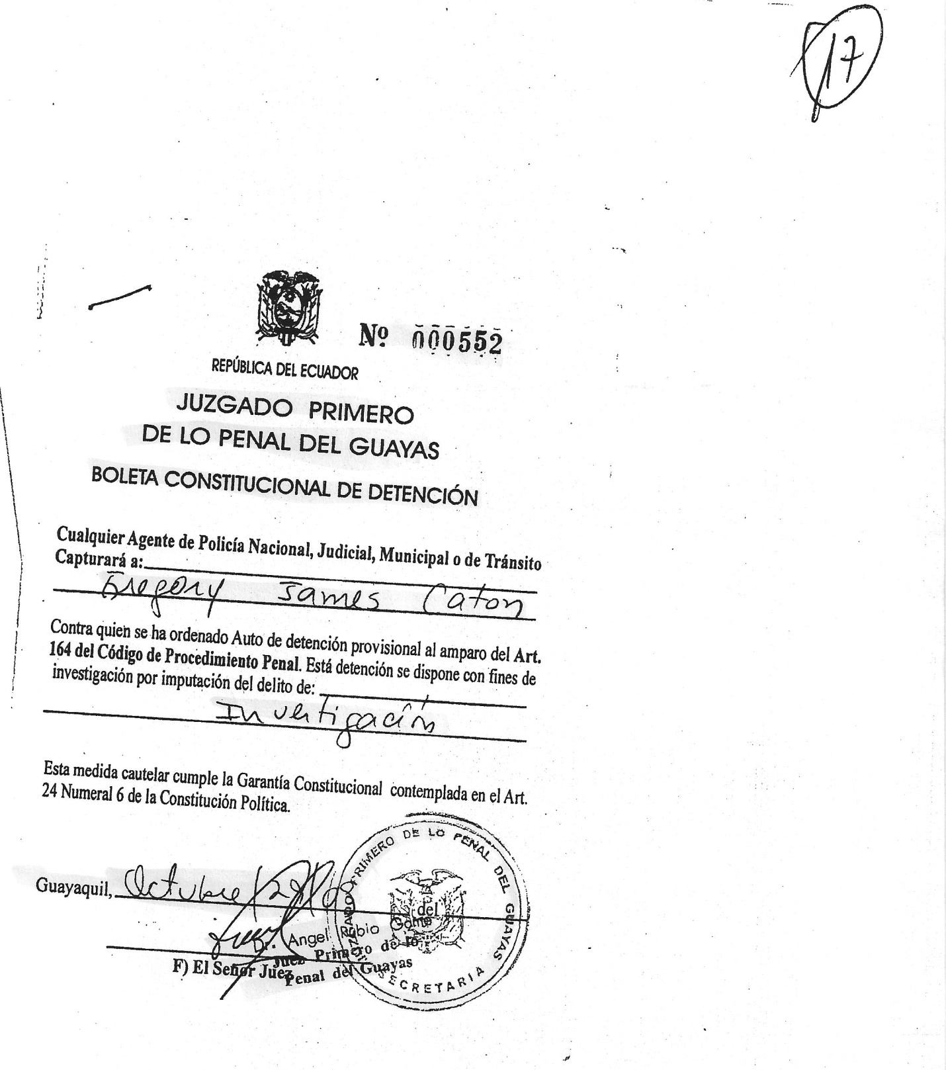

No. 000552

REPUBLIC OF ECUADOR

CRIMINAL COURT No. 1 OF GUAYAS

CONSTITUTIONAL ARREST ORDER

Any Agent of the National, Judicial, Municipal or Transit Police

Will Capture Gregory James Caton

Against whom a ruling of provisional arrest has been ordered under Article 164 of the Code of Criminal Proceedings. This arrest is ordered with the purpose of investigation for imputation of: Investigation.

This precautionary measure complies with the Constitutional Guarantee stipulated in Article 24, Numeral 6 of the Political Constitution.

Guayaquil, October *(Illegible date)*

*(Illegible signature)*

The Judge