The Illegal Deportation:
Post Kidnapping Affidavits from Eyewitnesses in Guayaquil

Background: Following the illegal kidnapping and deportation of Gregory James Caton in December, 2009, the defendant’s wife, Cathryn Caton, sought legal counsel to address the many violations of international and Ecuadorian law that occurred in connection with these events.
In the process of obtaining legal assistance and on the advice of counsel, the sworn Affidavits of three eyewitnesses were obtained – listed here in the same order as found in the documentation below:
( 1 ) Francisco David Chavez Vera – a former consultant / engineer, employed by Herbologics, Ltd.
( 2 ) Juan Carlos Chavez Jordan – a translator and facilitator, also employed by Herbologics, Ltd.
( 3 ) Dorlandig Humberto Toala Quijije – the attorney representing Gregory Caton from the time of the kidnapping on Dec. 2, 2009 to the day of the illegal deportation on Dec. 11, 2009.
Taken together, these documents show that Ecuadorian authorities directly and diliberately violated their oath of office by ignoring direct orders from an Ecuadorian judge.
What follows are the sworn affidavits, drafted in Spanish, followed by their English translation.

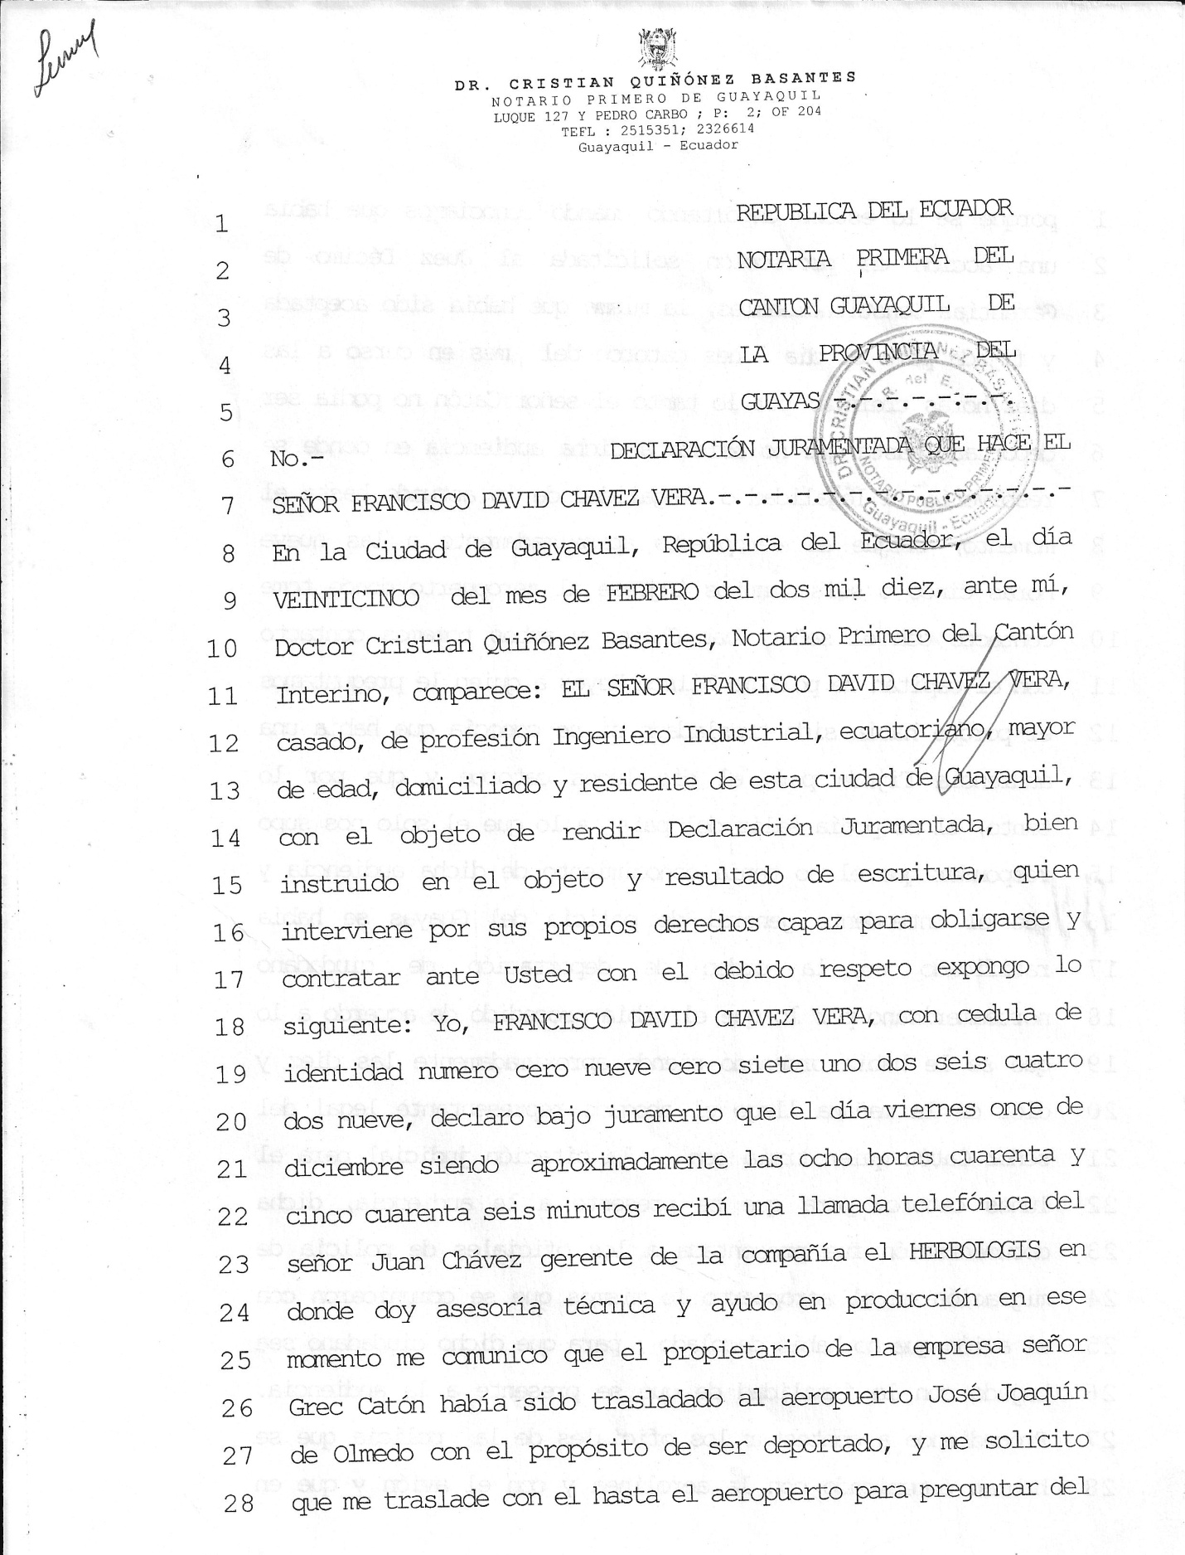

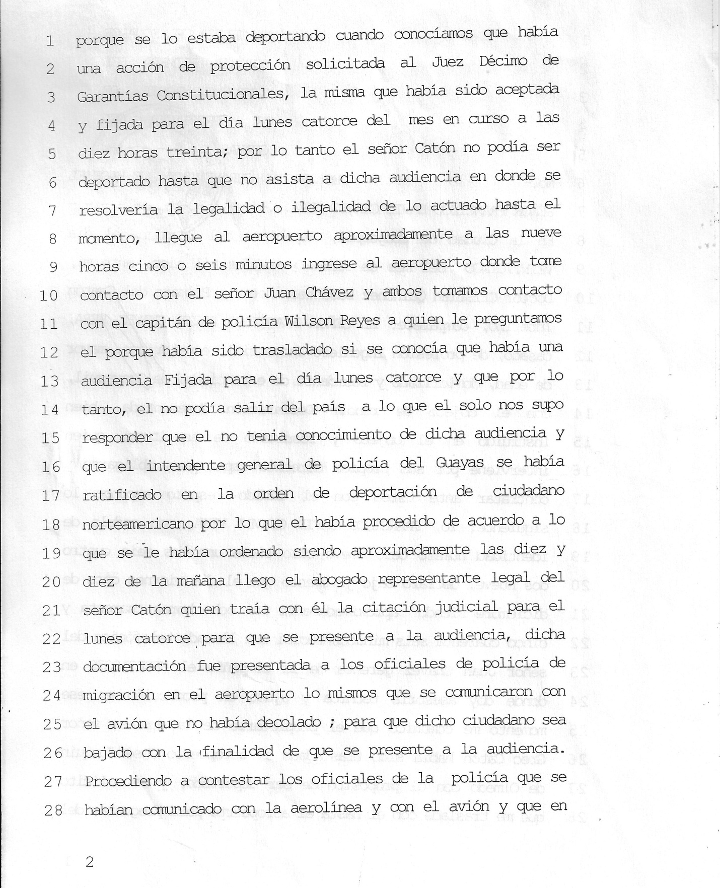

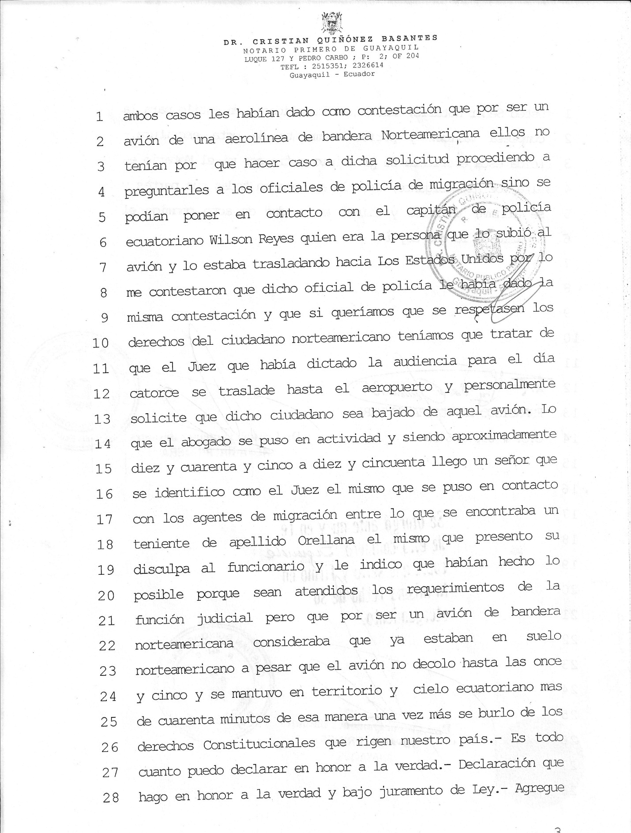

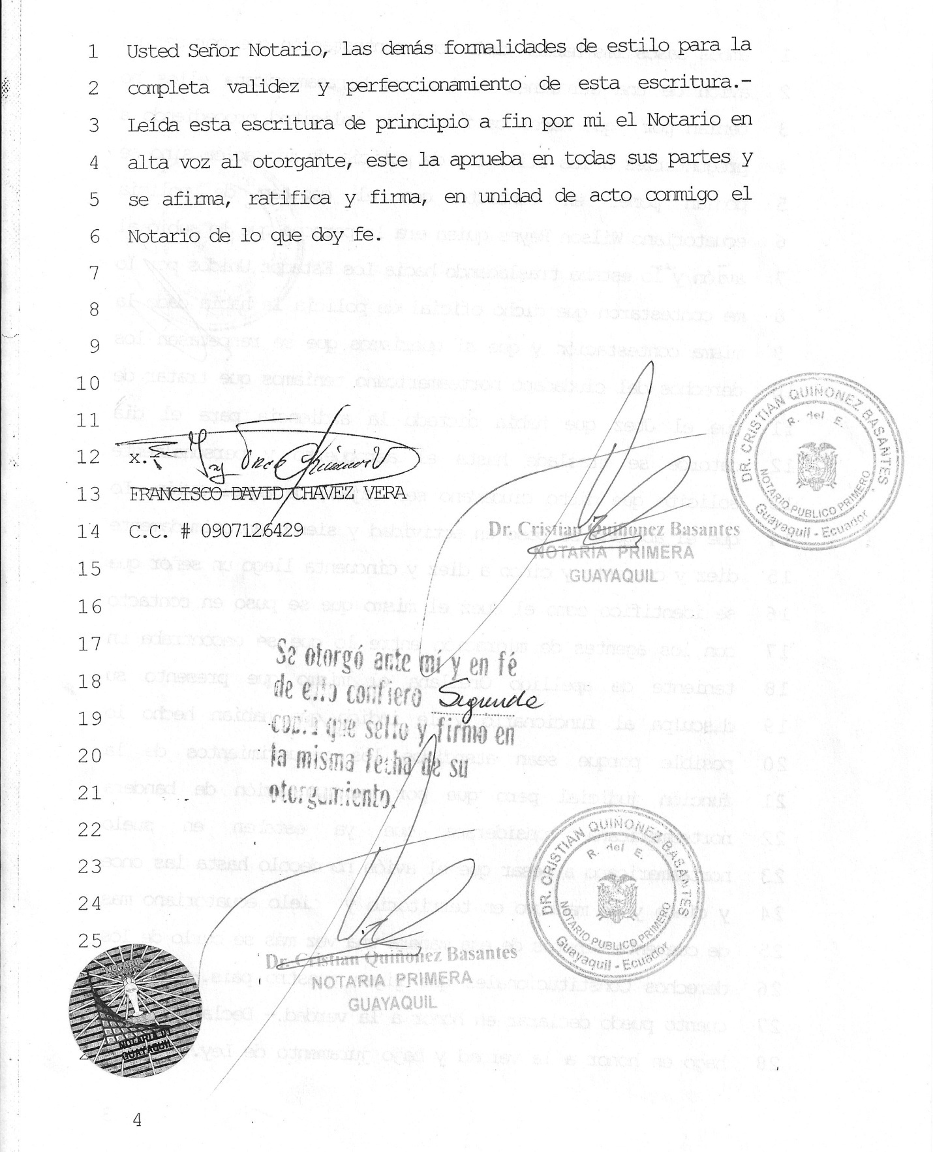

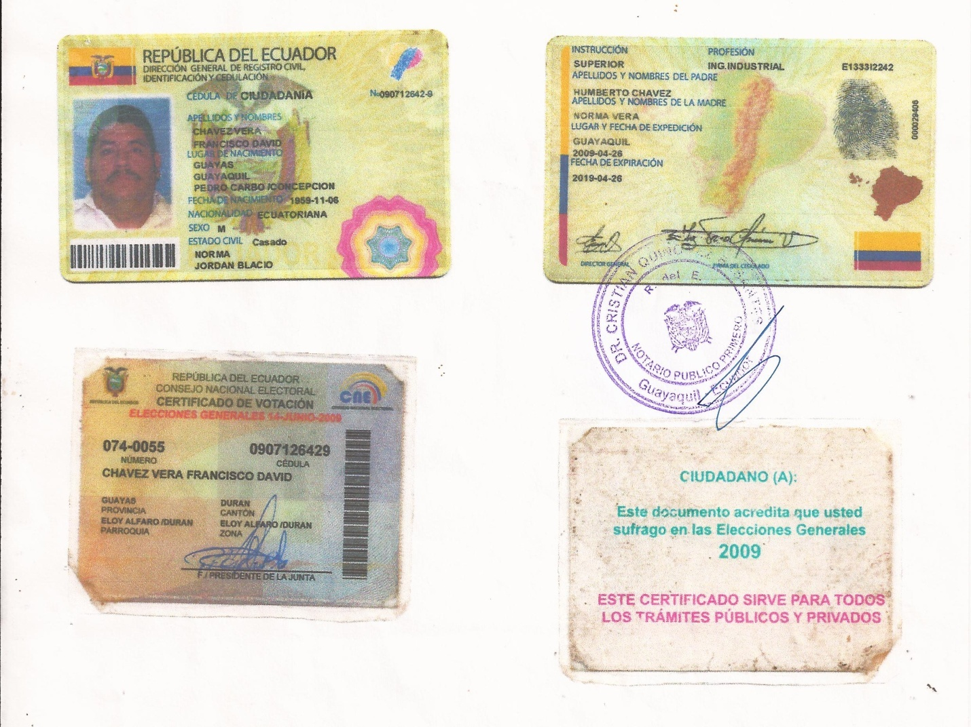

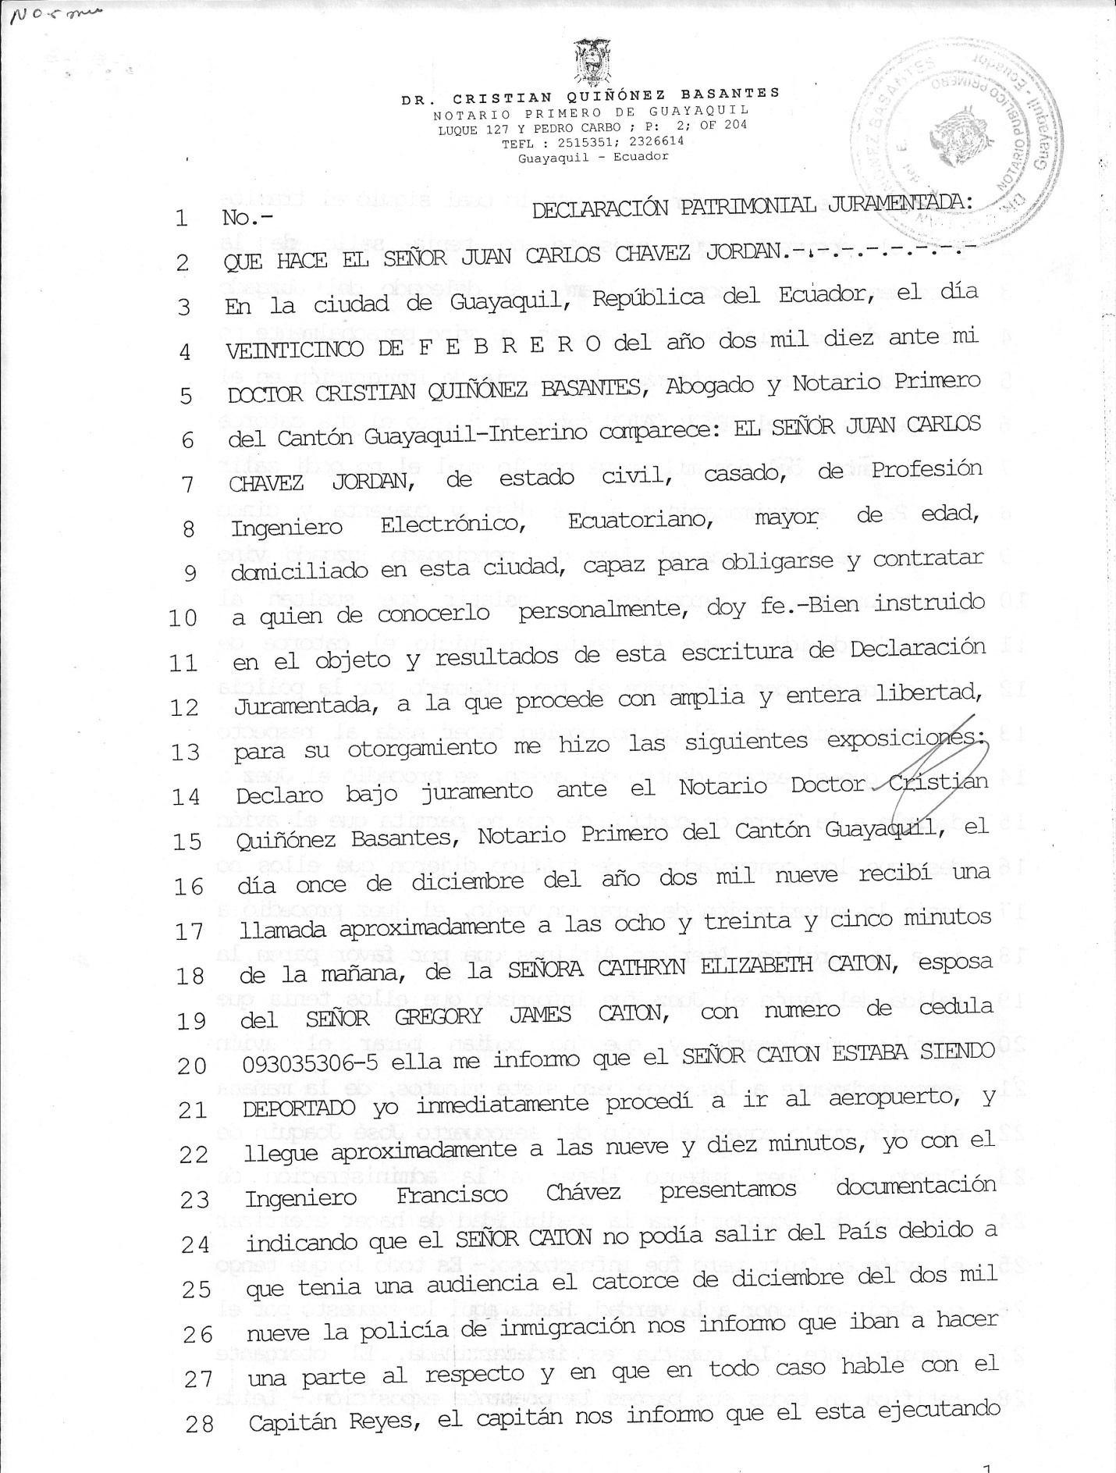

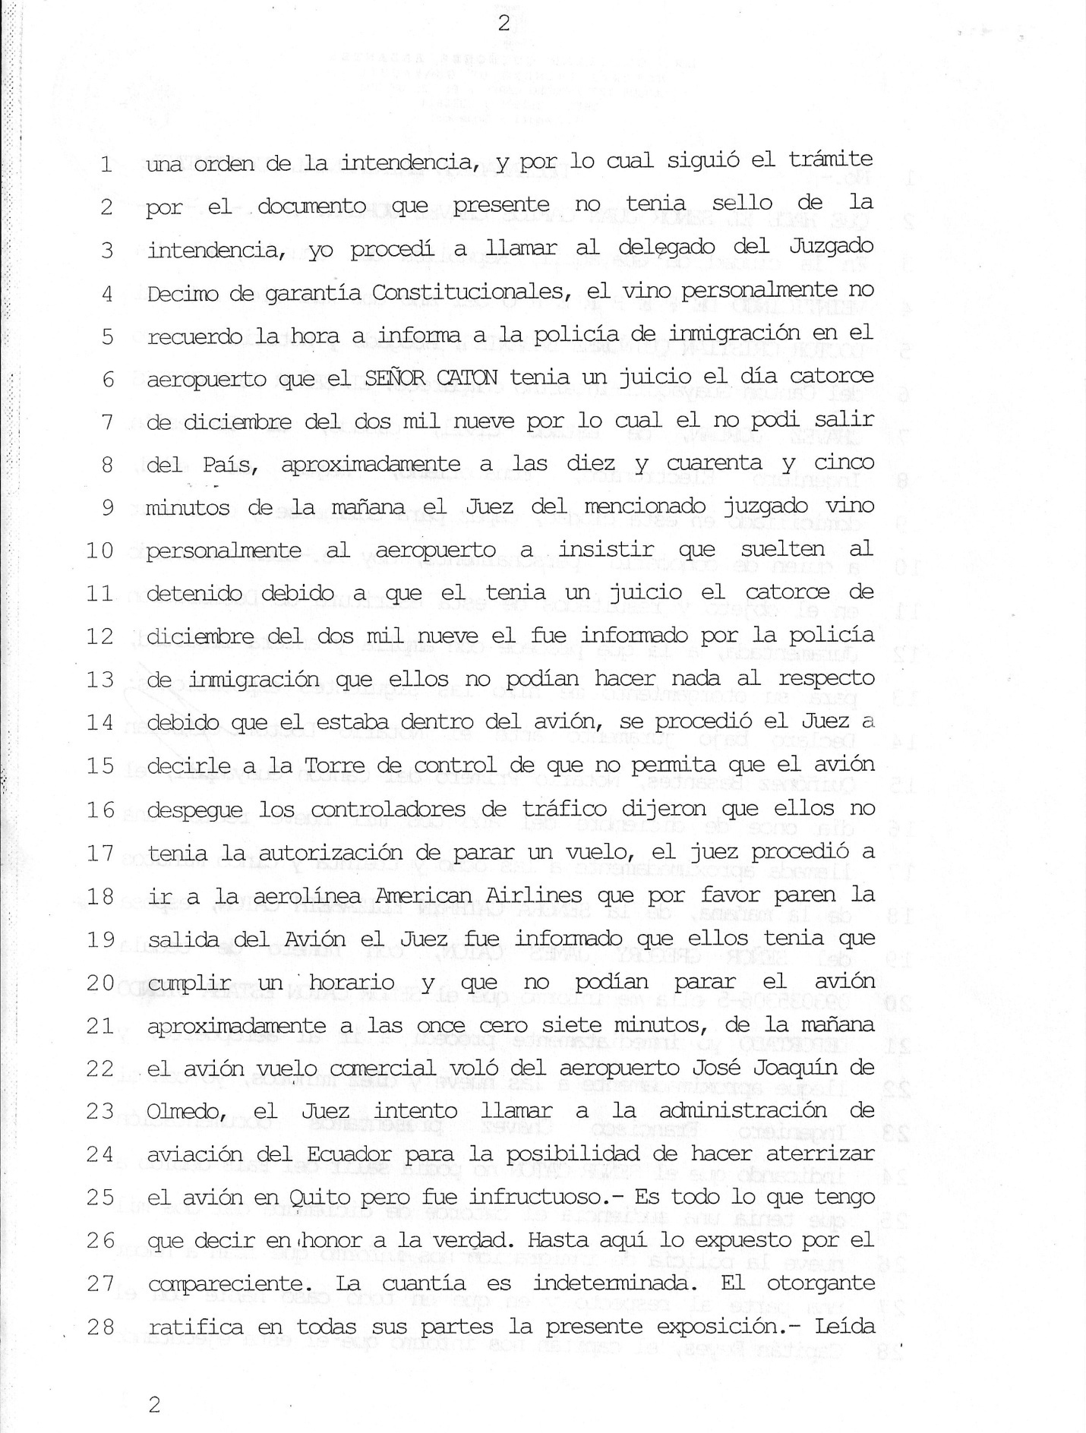

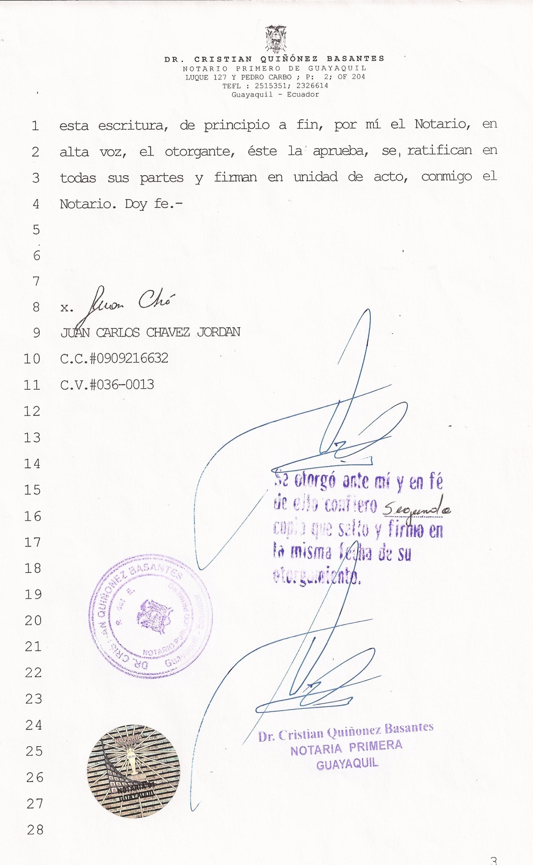
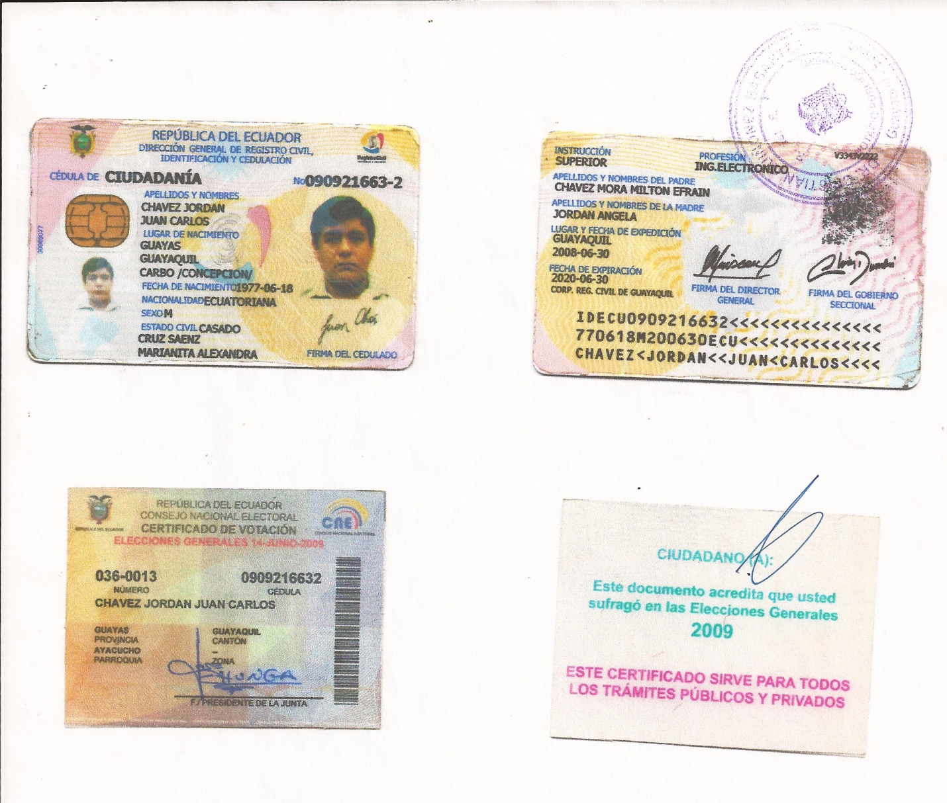

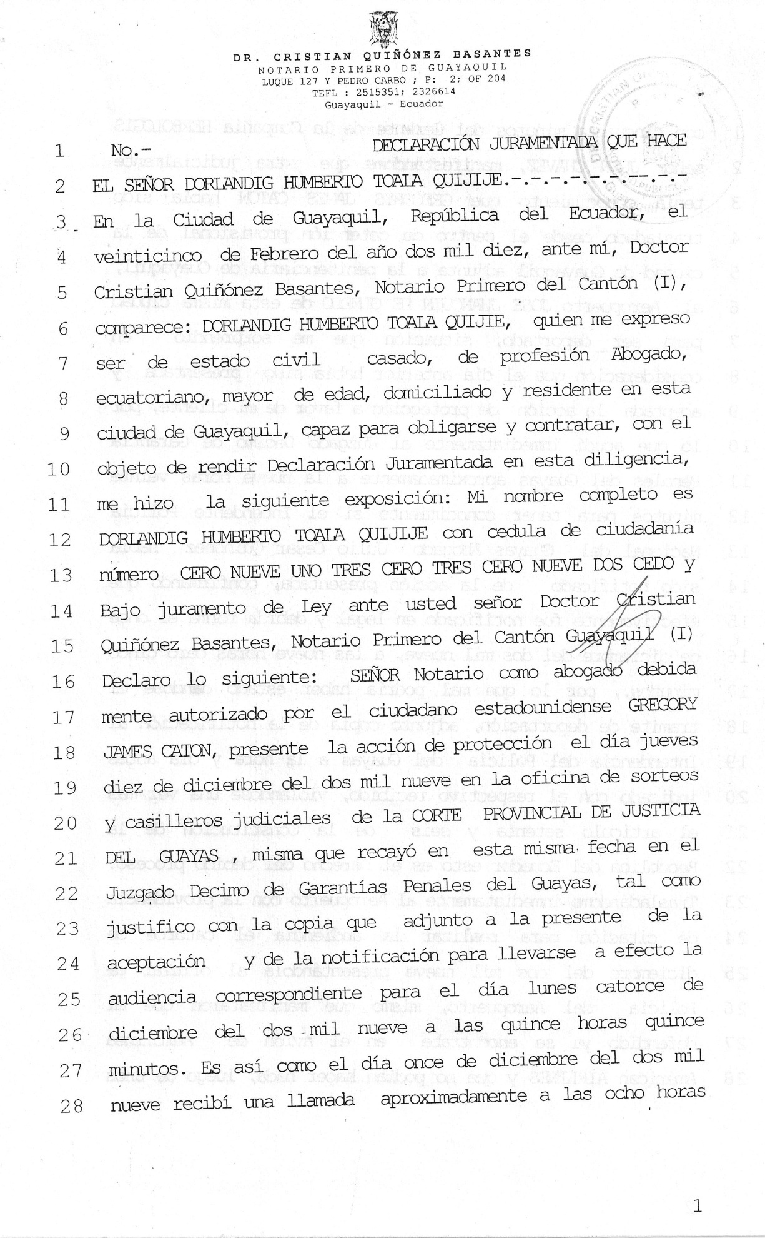
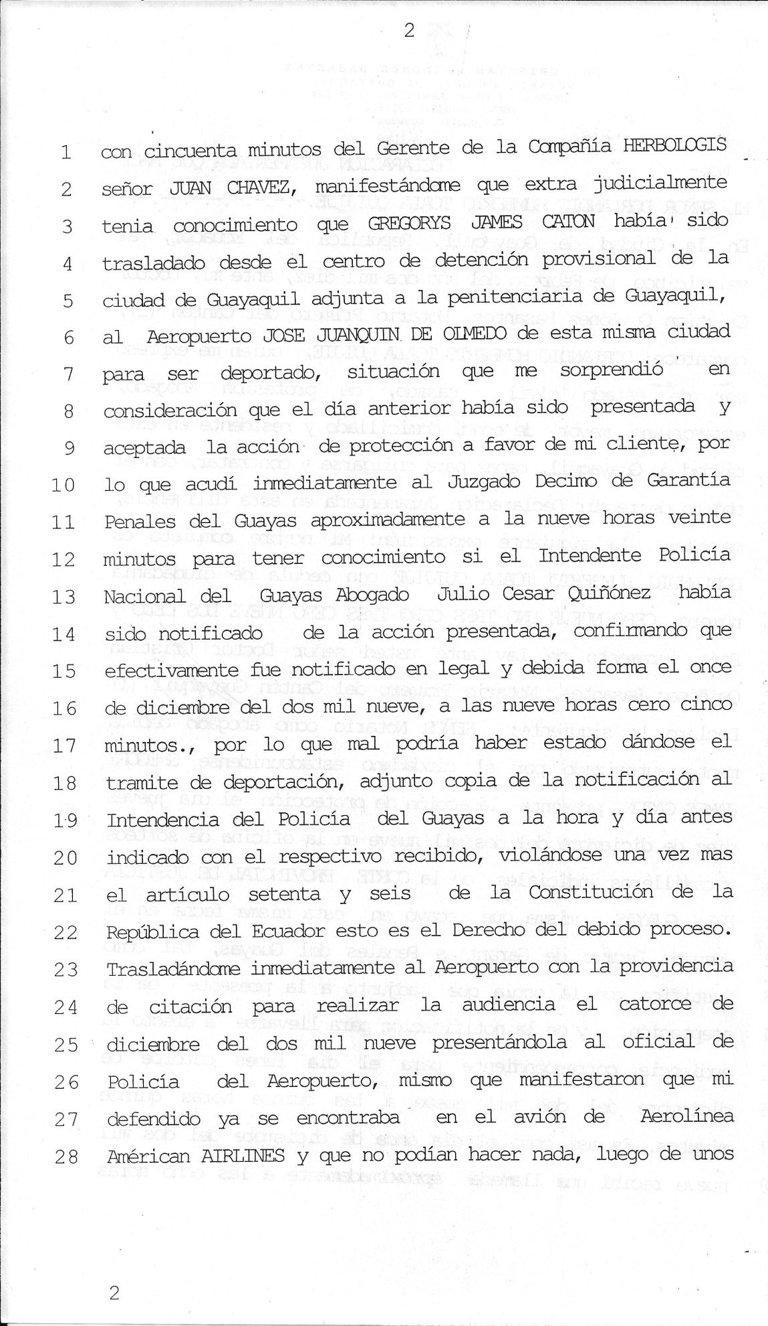
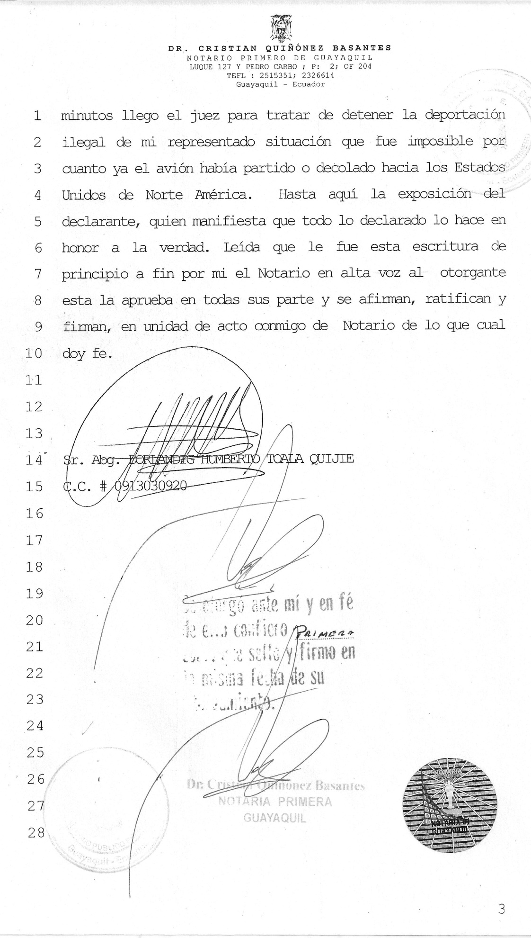
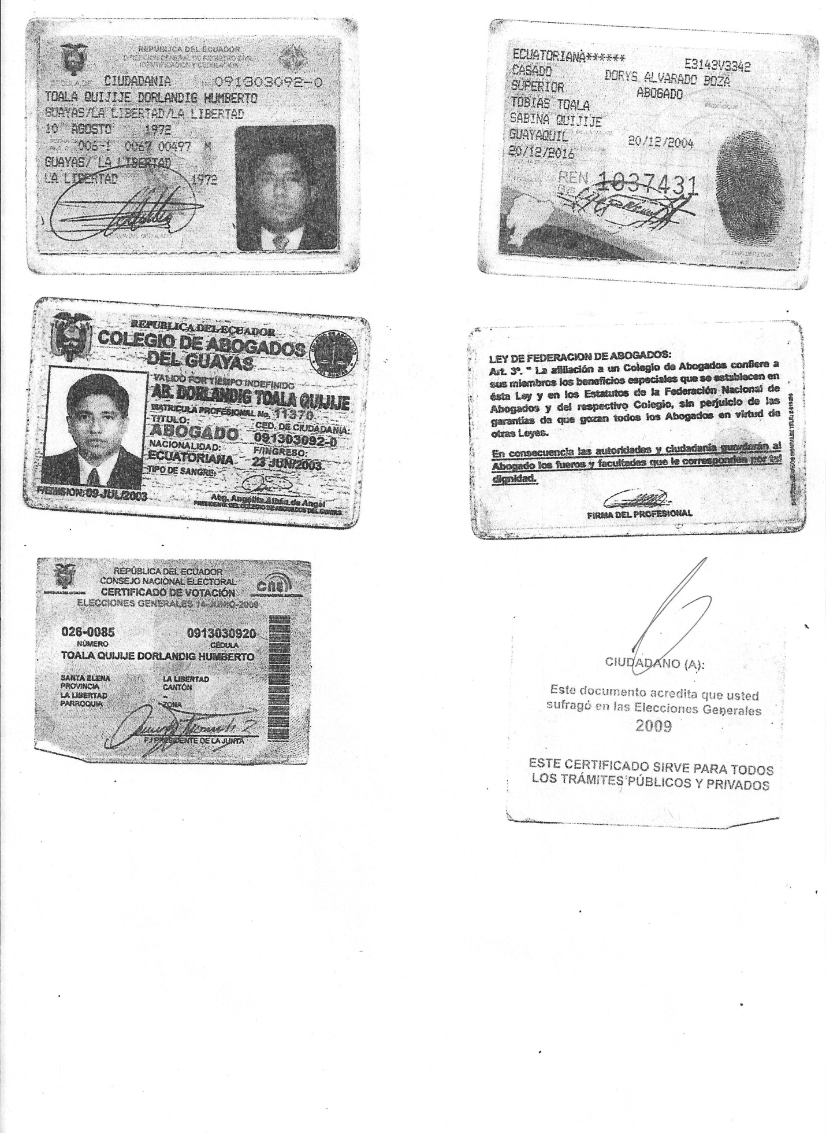
DR. CRISTIAN QUIÑONEZ BASANTES
FIRST NOTARY PUBLIC OF GUAYAQUIL
LUQUE 127 AND PEDRO CARBO, 2ND FLOOR, OFF 204
TEL: 2515351; 2326614
Guayaquil- Ecuador

REPUBLIC OF ECUADOR
FIRST NOTARY PUBLIC
OF GUAYAQUIL
PROVINCE OF GUAYAS
AFFIDAVIT OF MR. FRANCISCO DAVID CHAVEZ VERA

In the City of Guayaquil, Republic of Ecuador, on February 25, two thousand ten, before me, Doctor Cristian Quiñonez Basantes, First Notary Public of the Canton, appears: MR. FRANCISCO DAVID CHAVEZ VERA, married, with the profession of Industrial Engineer, Ecuadorian, adult, residing in this city of Guayaquil, with the object of making an Affidavit, well instructed in the object and result of deed, who intervenes with his own rights, with capacity to be bound and execute agreements, before You with respect do hereby swear to the following: I, FRANCISCO DAVID CHAVEZ VERA, with identification card number zero nine zero seven one two six four two nine, declare under oath that on Friday, December eleven, at approximately eight forty-five, forty-six I received a telephone call from Mr. Juan Chavez, manager of HERBOLOGICS, where I give technical consultancy and provide help in production. At that moment, I was told that the owner of the company, Mister Greg Caton had been transferred to the Jose Joaquin de Olmedo Airport with the purpose of being deported. I was requested to go to the airport in order to ask the reason why he was being deported when we knew that there was a petition of protection requested to the Tenth Judge of Constitutional Guarantees, the same that had been accepted and set for Monday the fourteenth of the current month at ten thirty. Therefore, Mister Caton could not have been deported until he assisted to such hearing where the legality or illegality of the actions until that moment would be resolved. I arrived at the airport at approximately five or six after nine, I entered in the airport where I got in contact with Mister Juan Chavez and we both got in contact with the Police Captain Wilson Reyes, to whom we asked the reason why Mr. Caton was transferred there, if it was known that a hearing was set for Monday fourteenth and therefore, he could not leave the country. The Captain could only respond that he did not know of such a hearing and that the General Mayor of the Police Department of Guayas had ratified the deportation order of the American citizen. This was the reason why he proceeded according to what he had been ordered to do. At about ten after ten in the morning, the attorney and legal representative of Mister Caton arrived bringing the subpoena to be present in the hearing on Monday fourteenth. Such documentation was presented to the Immigration Police officers at the airport. These officers got in communication with the aircraft [American Airlines] that had not yet taken off so the mentioned citizen could be

DR. CRISTIAN QUIÑONEZ BASANTES
FIRST NOTARY PUBLIC OF GUAYAQUIL
LUQUE 127 AND PEDRO CARBO, 2ND FLOOR, OFF 204
TEL: 2515351; 2326614
Guayaquil- Ecuador

brought off in order to assist to the hearing. They said that they got in communication with the airline and the aircraft and that in both cases; they were told that being an American airplane they did not have to obey such a request. Then I proceeded to ask the police officers if they could contact the Ecuadorian Police Captain Wilson Reyes since he was the one who took Mr. Caton to the airplane and was transferring him to the United States. They answered that he gave them the same answer and if we wanted the rights of the North American citizen to be respected, we had to try to bring the Judge who issued the hearing for the fourteenth and have him personally request that such a citizen be brought off the airplane. Therefore, the attorney started his activity and at about ten forty-five and ten fifty, a man who identified himself as a judge arrived, he contacted the immigration agents, among them there was a Lieutenant Orellana. This person apologized with the judge and told him that he tried to enforce the requirements of the law, but the airplane with American flag considered that it was in North American territory even though the airplane had not taken off until five after eleven and was in Ecuadorian territory and sky more than forty minutes. That way, once more, the Constitutional rights that regulate our country were not respected. That is all that I can say in honor of the truth and under oath. Notary, please add the rest of formalities of style for the complete validity and perfection of this deed. This deed was read by me, the Notary, from beginning to end aloud to the grantor. He approves it in all its parts and affirms, ratifies and signs with me, the Notary, at the same time and place which I attest.

(Signature)
FRANCISCO DAVID CHAVEZ VERA
C.C. # 0907126429
(Signature)
Dr. Cristian Quiñonez Basantes
FIRST NOTARY PUBLIC - GUAYAQUIL

I attest that a Second copy was granted,
The same that I stamp and sign on the same
Date of granting it.

(Signature)
Dr. Cristian Quiñonez Basantes
FIRST NOTARY PUBLIC- GUAYAQUIL

DR. CRISTIAN QUIÑONEZ BASANTES
FIRST NOTARY PUBLIC OF GUAYAQUIL
LUQUE 127 AND PEDRO CARBO, 2ND FLOOR, OFF 204
TEL: 2515351; 2326614
Guayaquil- Ecuador

No. - SWORN STATEMENT OF FINANCIAL POSITION:
BY MISTER JUAN CARLOS CHAVEZ JORDAN

In the city of Guayaquil, Republic of Ecuador, on FEBRUARY twenty-fifth, two thousand ten, before me, DOCTOR CRISTIAN QUIÑONEZ BASANTES, Attorney and acting First Notary Public of Guayaquil Canton, appears: MISTER JUAN CARLOS CHAVEZ JORDAN, married, with the profession of Electronic Engineer, Ecuadorian, adult, residing in this city, with capacity to be bound and execute agreements, whom I certify to know. Well instructed with the object and results of this affidavit deed, to which he proceeds with complete freedom. For its granting, he stated the following: I declare under oath before the Notary Public Doctor Cristian Quiñonez Basantes, First Notary Public of the Canton of Guayaquil, that on December eleventh of two thousand nine, I received a telephone call from MRS. CATHRYN ELIZABETH CATON at approximately eight thirty five in the morning. She is MISTER GREGORY JAMES CATON’S wife and her identification card number is 093035306-5. She informed me that MISTER CATON WAS BEING DEPORTED. I immediately went to the airport and arrived there at ten after nine. Once there, the Engineer Francisco Chavez and I presented documents indicating that MISTER CATON could not leave the country due to a hearing that in which he would have to assist on December fourteenth, two thousand nine. The Immigration Police informed us that they were going to write a report in this respect and asked us to talk to Captain Reyes. He informed us that he was executing an order from the mayor’s office. And he followed the procedure because the document that I presented did not have a stamp of the mayor’s office. Then I proceeded to call the representative of the Tenth Court of Constitutional Guarantees, he came personally but I do not recall the time. He informed the Immigration Police at the airport that MISTER CATON had a trial on December fourteen of two thousand nine and could not leave the country. At approximately ten forty-five in the morning, the judge of the mentioned court personally came to the airport in order to insist that the arrested must be released because he has a trial hearing on December fourteen, two thousand nine. He was informed by the Immigration Police that they could not do anything regarding that because the accused was in the airplane. Then the judge went to American Airlines and requested them to stop that plane but he was informed that they had to comply with a schedule and they could not stop it. At approximately seven after eleven in the morning, that airplane with a commercial flight flew from Jose Joaquin de Olmedo Airport. The judge tried calling the administration office of aviation of Ecuador to ask for the possibility to have the plane land in Quito, but it was unsuccessful. – This is all I have to say in honor of the truth. The affiant’s statements are until here. The grantor ratifies the present document in all its parts. This deed was read by me, the Notary, from the beginning to end aloud to

DR. CRISTIAN QUIÑONEZ BASANTES
FIRST NOTARY PUBLIC OF GUAYAQUIL
LUQUE 127 AND PEDRO CARBO, 2ND FLOOR, OFF 204
TEL: 2515351; 2326614
Guayaquil- Ecuador

the grantor. He approves and ratifies it in all its parts and signs with me, the Notary, at the same time and place which I attest.

(Signature)
JUAN CARLOS CHAVEZ JORDAN
ID. #0909216632
CV. #036-0013

(Signature)
I attest that a Second copy was granted,
The same that I stamp and sign on the same
Date of granting it.

(Signature)
Dr. Cristian Quiñonez Basantes
FIRST NOTARY PUBLIC- GUAYAQUIL

DR. CRISTIAN QUIÑONEZ BASANTES
FIRST NOTARY PUBLIC OF GUAYAQUIL
LUQUE 127 AND PEDRO CARBO, 2ND FLOOR, OFF 204
TEL: 2515351; 2326614
Guayaquil- Ecuador

No. AFFIDAVIT MADE BY
MISTER DORLANDIG HUMBERTO TOALA QUIJIJE
In the City of Guayaquil, Republic of Ecuador, on February twenty-fifth of two thousand ten, before me, Doctor Cristian Quiñonez Basantes, First Notary Public of the Canton, appears: DORLANDIG HUMBERTO TOALA QUIJIJE, who said to be married, with the profession of a Lawyer, Ecuadorian, adult, residing in this city of Guayaquil, with capacity to be bound and execute agreements, with the objective of making this Affidavit in this office, he stated the following: My complete name is DORLANDIG HUMBERTO TOALA QUIJIJE with identification card number ZERO NINE ONE THREE ZERO THREE ZERO NINE TWO ZERO and under oath, before you Doctor Cristian Quiñonez Basantes, First Notary Public of the Canton of Guayaquil, declare the following: As an attorney legally authorized by the American citizen GREGORY JAMES CATON, I presented the Petition of Protection on Thursday, December ten, two thousand nine at the office of case assignments of the PROVINCIAL COURT OF JUSTICE OF GUAYAS. On the same date, it was assigned to the Tenth Court of Criminal Guarantees of Guayas as I justify annexing the copy of the acceptance and service of process for the corresponding hearing to be held on Monday, December fourteen, two thousand nine at fifteen hours and fifteen minutes. On December eleven, two thousand nine, I received a telephone call from Mr. JUAN CHAVEZ, manager of the company HERBOLOGICS at approximately eight fifty. He told me that he had knowledge that GREGORY JAMES CATON had been transferred from the provisional detention center of Guayaquil to the JOSE JOAQUIN DE OLMEDO Airport of the same city in order to be deported. This fact surprised me because the acceptance of the petition of protection in favor of my client was accepted the day before. So, I immediately went to the Tenth Court of Criminal Guarantees at approximately nine twenty in order to find out if the Police Mayor of Guayas, Atty. Julio Cesar Quiñonez had been notified of the presented petition. Effectively, he confirmed that he was legally notified on December eleven, two thousand nine at five after nine in the morning. Therefore, the deportation order was wrongly given. I attach a copy of the service of process to the Police Mayor of Guayas at the aforesaid hour and day with the respective seal of being received. This way, the Article seventy-six of the Constitution of the Republic of Ecuador was violated once more, the right to a legal process. Then, I immediately went to the airport with the order of subpoena for the hearing on December fourteen, two thousand nine. I presented it to the police officer there and he told me that my client was already in the airplane of American Airlines and that he could not do anything about it. After a few minutes, the judge arrived in order to try to stop the illegal deportation of my client but it was impossible since the airplane had taken off to the United States of America.

DR. CRISTIAN QUIÑONEZ BASANTES
FIRST NOTARY PUBLIC OF GUAYAQUIL
LUQUE 127 AND PEDRO CARBO, 2ND FLOOR, OFF 204
TEL: 2515351; 2326614
Guayaquil- Ecuador

Until here is stated by the affiant who indicates that everything declared is in honor of the truth. This deed was read by me, the Notary, from beginning to end aloud to the grantor. He approves and ratifies it in all its parts and signs with me, the Notary, at the same time and place which I attest.

(Signature)
Atty. DORLANDIG HUMBERTO TOALA QUIJIJE
I.D. # 0913030920

(Signature)
I attest that a First copy was granted,
The same that I stamp and sign on the same
Date of granting it.

(Signature)
Dr. Cristian Quiñonez Basantes
FIRST NOTARY PUBLIC- GUAYAQUIL

